2023-2024 Student Forms Only
For Verification forms or Consumers/Disclosure Statements, please refer to those sets of forms also provided by RGM on different files.

BEFORE YOUR INSTITUTION DECIDES TO USE ANY OF THE ENCLOSED FORMS, PLEASE NOTE THE FOLLOWING:

All the forms are created using the latest guidance (to the best of our knowledge) from State and Accrediting agencies along with the United States Department of Education and with assistance of peers in the field. The use of the forms is an institutional decision as to which form to use or not use, and how the institution determines to use them. All forms are in Word.doc, so institutions may make any appropriate changes to the document. If an institution wishes to make changes to a document that is generated by the RGM system, that institution must inform RGM of the change(s) to update the generated forms in the system. All forms used, must be thoroughly completed and signed by all required parties.

Prepared for:
«sssscc»
«schlceoattn»
«schlname»
«schlstreet»
«schlcity» «schlstate» «schlzip»

Student forms are in Word Format to be completed manually with Student’s name, and student's key number. FOLLOWING FERPA REGULATIONS WE MUST ELIMINATE DISPLAYING THE STUDENT AND PARENT’S SOCIAL SECURITY NUMBERS.

• This is Your Original Copy of the RGM Forms Package.
• It is customized with your school's name and address.
• Please reproduce the pages for your own internal use.

R. Gonzalez Management, Inc.
3560 S. La Cienega Blvd. Suite G
Los Angeles, CA 90016-4400
Phone (323) 730-8700
Fax (323) 730-8701
http:/www.rgmsms.com

NOTE: Delete any forms or those Items in the forms packet not applicable to your institutional student files.

all forms included in this set are provided to your school annually. the most recent revision date appears in the footer of each page. all forms are prepared for your school usage using word.doc. In addition, the forms are included with a set of instructions which will lead the user, by transaction number, through the rgm system to access most forms. the forms are available once a student is selected.

The following document is divided into two sections; first, it offers a description of each form provided by rgm, followed by the forms in a respective order.

RGM Document Chart

The following chart provides a list of the RGM Forms with their corresponding form number and where each form is located. There are three sets of forms:

1) Consumer Disclosures required under the USDE consumer information guide, these forms are to be inserted in your annual catalog.

2) Institutional Verification Forms, these forms apply to those students selected for verification and are generated by the RGM system in accordance of the group selected.

3) Student Forms that are to be used as they apply to each individual student on a case by case basis, these forms are generated from the RGM system from each module as applicable.

All 3 sets of files are available under the RGM Website www.rgmsms.com under the “Clients Only” section. To access this section and download the files, use your RGM login USER ID and the email REGISTER in your employee profile as your password. Your password to the RGM system has no function in the CLIENTS ONLY section. Please contact our staff for any questions.
Form 2020-2021# | Form title | Consumer Info. | Student | Verification | Forms are Generate By the RGM System using TRX # from each applicable Module
10001 | Documentation checklist |  | Yes |  | 3019 - Admissions
10003 | Application for Admission |  | Yes |  | Paper only
10004 | Notice of available G.E.D. training | Yes |  |  | Sample for Catalog
10005 | FEDERAL DISCLOSURE REQUIREMENTS – “Student Right to Know” " How are our students doing" | Yes |  |  | Sample for Catalog
10006 | Campus Security Act Disclosure Statement - Clery Act | Yes |  |  | Sample for Catalog
10007 | Drug & Alcohol Abuse Policy Statement | Yes |  |  | Sample for Catalog
10008 | Admissions Disclosure Form | Yes |  |  | Sample for Catalog
10010 | California BPPE School Performance Fact Sheet |  | Yes |  | Report from RGM
10012 | Enrollment Agreement (sample) |  | Yes |  | 3019 Admissions
10013 | Acknowledgment of Disclosures Received |  | Yes |  | 3019 Admissions
10014 | Institutional Verification Document |  |  | Yes | 5026 Fin Aid
10015 | Professional Judgment and/or Dependency Override Worksheet |  | Yes |  | 5007 Fin Aid
10016 | Understanding Disbursement of Federal Funds and Credit Balance |  | Yes |  | 5007 Fin Aid
10017 | Special Selection of SEOG Recipient |  | Yes |  | 5007 Fin Aid
10018 | Advising and/or Counseling Report |  | Yes |  | 4030 Registrar
10019 | Financial Aid Office Review and Disbursement Approval credit/clock hour non-term programs |  | Yes |  | 5007 Fin Aid
10020 | Credit Balance Form |  | Yes |  | 6033 Fiscal
10021 | Leave of Absence (LOA) |  | Yes |  | 4030 Registrar
10022 | Internal Notice of Termination/Graduation |  | Yes |  | 4030 Registrar  5007 Fin Aid  6033 Fiscal
10023 | Employment Waiver |  | Yes |  | Paper only
10024 | Student Loan Borrower Reference Tracking Form |  | Yes |  | Paper only
10025 | Authorization Form to Release Information (FERPA) |  | Yes |  | 4030 Registrar  5007 Fin Aid  6033 Fiscal
10026 | Gainful Employment Program Disclosure | Yes |  |  | Report from RGM
10027 | Contract Addendum |  | Yes |  | 4030 Registrar  5007 Fin Aid
10028 | Institutional Record of Admission Applications |  | Yes |  | Paper only
10029 | Sample Employment Verification Form |  | Yes |  | Paper only

Important links for 2024

Student Guide

Institutions are required to provide basic information on financial aid programs to all prospective students and current students. The use of these USDE annual publications by the institution would comply.

English: https://studentaid.ed.gov/sa/resources

Spanish: https://studentaid.ed.gov/sa/es/resources

Direct Loan Basics for Students PDF [includes correction to print version]
Explains subsidized and unsubsidized Direct Stafford loans for students.
https://studentaid.ed.gov/sa/sites/default/files/direct-loan-basics-students.pdf

Direct Loan Basics for Parents PDF Explains Direct PLUS loans for parents.
https://studentaid.ed.gov/sa/sites/default/files/direct-loan-basics-parents.pdf

FAFSA: Free Application for Federal Student Aid

FAFSA 2023-2024

This is a required form for ALL students participating in ANY Title IV Federal Student Aid Program (Except PLUS only applicants)

This form is the only official application for free Federal student aid (FAFSA). If the form is completed on the FAFSA website by the student and parents, or if the student mails the form in, the institution will not have a copy of the FAFSA in the file. HOWEVER, if the FAFSA is completed at the school and is submitted by the school to CPS on behalf of the student, the FAFSA with original signatures MUST be retained in the student’s file.

FAFSA on the Web

http://www.fafsa.ed.gov/

2023-2024 FAFSA English PDF

https://studentaid.gov/sites/default/files/2023-24-fafsa.pdf

2022-2023 FAFSA Spanish PDF

https://studentaid.gov/sites/default/files/2023-24-fafsa-spanish.pdf

2023-2024 Federal Pell Grant and Disbursement schedules

https://fsapartners.ed.gov/sites/default/files/2023-01/2023-24PaymentSchedule.pdf

Direct Loan Links

General information

General and important information to the student about the Federal Direct Loan can be found at the following URL

https://studentaid.ed.gov/sa/

https://studentaid.gov/understand-aid/types/loans

Federal Direct Loan Promissory Note

Information about the Federal Direct Loan promissory note may be located at the following URL

https://studentloans.gov/myDirectLoan/whatYouNeed.action

Federal Direct Loan Entrance and Exit Interviews

All student borrowers are required to complete an entrance interview before a first loan disbursement is made and an exit interview prior to leaving the school.

https://studentloans.gov/myDirectLoan/index.action

For More Information on Direct Loans

https://studentloans.gov/myDirectLoan/index.action available in English and Spanish

10001 Documentation CHECKLIST

This is not a required form in the student file

The form is used to track forms required and/or applicable by/to the institutional procedures

Status of this form: The form is provided in the RGM system under Admission: Student Admission Transactions: Student Admission Forms Transaction #3019. The form is created based on the Title IV Aid programs available at each school. Once it takes you to the next screen you will need to select a student and click on add/view other forms and check the box next to the form [10001] and click the link, the form will pop up.

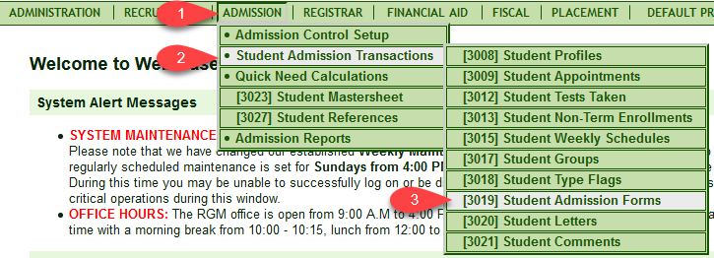

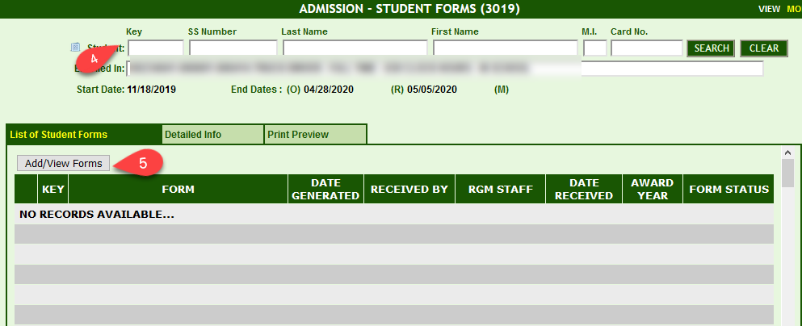

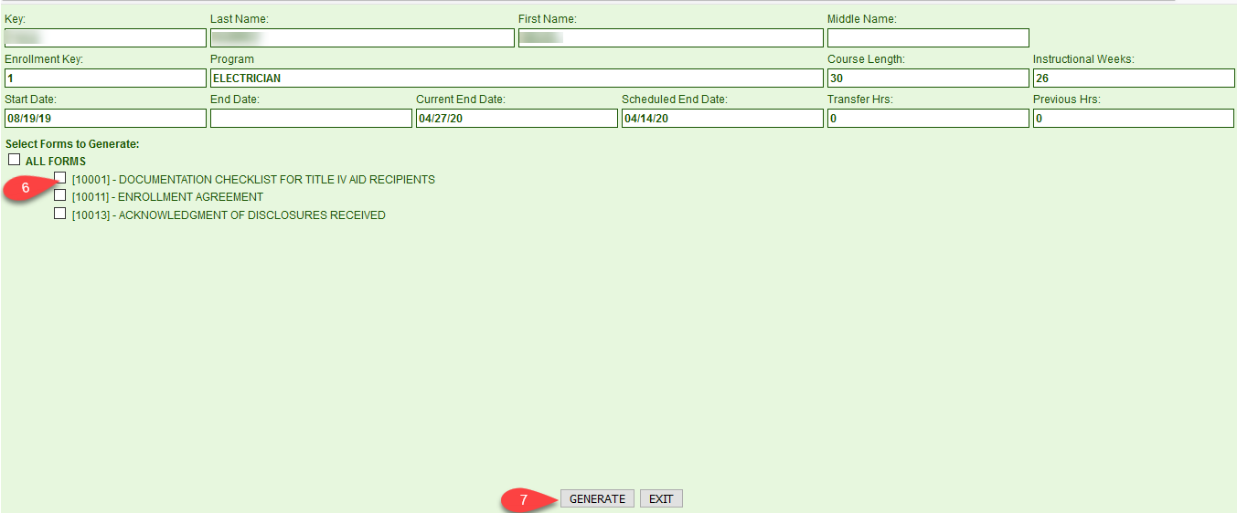

10003 APPLICATION FOR ADMISSION

This is not a required form

The form serves to obtain student information at the time of enrollment, which has been proven to be the best time to get information to track the student later during the placement and default prevention procedures. Have students completely fill out the form and review the data provided to ensure consistency in the student file.

The form contains helpful information for the FAO such as dependency status, if the student must register with the selective service, if student qualifies for VA benefits, the student’s educational level, employment history and parental and other references which will be very useful to track the student later during the placement and default prevention process.

Status of this form: Provided by RGM in Word.doc format for your use, this form will not be generated as a form in the RGM Web System since it is a form to be completed by prospective students up front at the start of the enrollment process. The application provides more information from the student and assists the FAO in accomplishing a better financial aid package. However, FAOs must be cautious for a higher possibility of inconsistencies in the student file.

Please review the RGM Memo sent to our clients on 11/02/2013 about an extensive explanation of form 10003.

10010 SCHOOL PERFOMANCE FACT SHEET

This is a required form for all schools operating in California under the State Approval of BPPE

This is to be given to the students prior to the signing of the enrollment agreement.

To complete this form, you can print the report from the RGM Web System under Administration: Annual Reports: [1071] BPPE Fact Sheet. Select from the options on the drop down then click generate report:

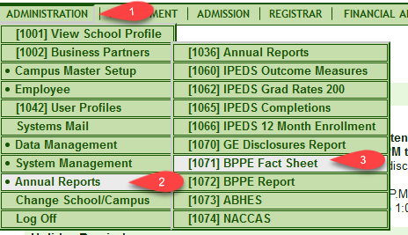

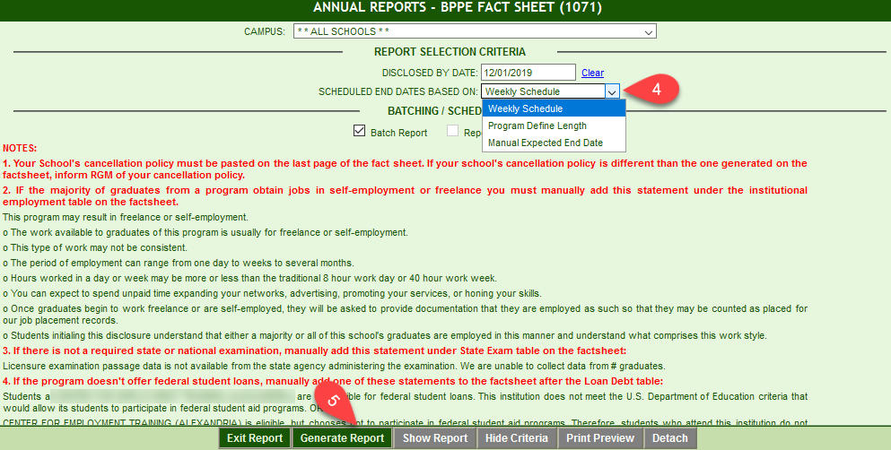

This is a form that BPPE requires institutions to distribute to prospective students before the student executes (signs) an enrollment agreement and to retain with all Initials and signatures required in the form, The institutions are required to retain it in the student file as a permanent record. The five year record retention requirement does not apply to this form and to the enrollment agreement as well. These two original forms must be in the institutional student file after the five years post the student’s LDA. Once the five years elapsed, the institution may scan these two documents and retain the electronic records for life.

This report, as many other reports generated by the RGM system, allows the user to click on the blue hyperlinks (numbers) to display and print the students listed on each field of the report. Schools MUST generate the report, check the students listed in each field of the report. Once approved, print each field and save it as part of the report back-up and supporting documentation of the data submitted to the agencies at the time of the submission. The data in the system is continuously updated. Therefore, subsequent reports for the same period may have new student data and will not match the data reported at a given time. Please print the approved report and enter the data into the paper form so the student can initial and acknowledge each rate and sign at the end of the form. Please save the form in the student file, and also scan it and save it electronically.

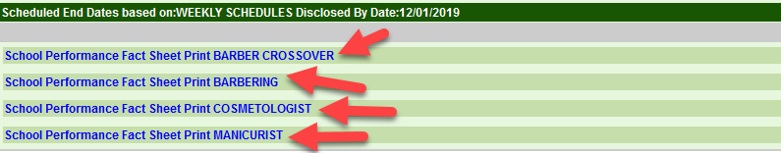

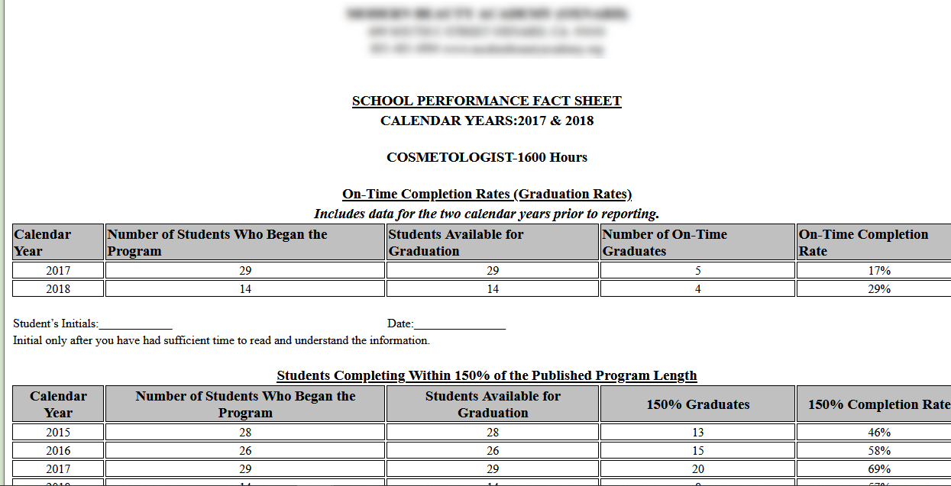

Status of this form: Provided by RGM in Word.doc format for your use, this form will generate as a form by the RGM Web System.

10012 Enrollment agreement

This is a required document

special note regarding the attached enrollment agreement (BPPE) (REVISED RULES as of (December 2014)

The form was designed to provide guidance to copy and paste to your own contract. Some of the wording applies specifically to the requirements from the new BPPE in California. This allows a registration fee up to $250.00 and prorates tuition up to 60% of the course time elapsed.

There are three documents related to the student enrollment agreement:

First, there is a sample of the agreement that can be copied and pasted for your school use. Please make sure that the wording is adjusted to meet your needs.

Second, there is an identical copy with (added-inserted) numerical code that corresponds to the BPPE code from the checklist provided by BPPE during compliance school visits. This is provided to identify where and at what location each of the BPPE’s required elements is in the document. Please do not use this document, this is only a reference document. Use the first copy without the numerical codes as your working copy.

Third document provides the checklist of required items in the enrollment agreement as originated from compliance visits by BPPE.

Every student enrolled must have an enrollment agreement executed by the student (and parent if under 18 years of age) and the institutional representative and his/her file. In most cases, the state agency and the accrediting agency will dictate the items required in the enrollment agreement.

The enrollment agreement must be executed after the following transactions have been completed:

A copy of the school catalog (via the school website or on paper) has been provided to the prospective student,

The institutional Performance Fact Sheet (Form 10010) has been provided and explained to the prospective student. The Performance Fact Sheet must have the student’s initials and signature required.

The enrollment agreement must be signed before the start date. The student should not earn academic hours or credits for completing admission or financial aid documentation.

Students that have withdrawn from school AND return to school within 180 days do not need a new enrollment agreement, but new expected end date must be recorded on same document and on a contract addendum.

The Performance Fact Sheet and the Enrollment Agreement cannot be destroyed after the five year record retention requirement. These two documents must be accessible at any time in the future.

Status of this form: Provided in Word.doc format for your use, this form is also generated in the RGM system. Please go to Admission: Student Admission Transactions: Student Admission Forms Transaction # 3019. Once you get to the transaction, you will select a student and click on Add/View Enrollment Agreement. A pop up box will appear and you will check the box then click generate. The Enrollment Agreement will pop up and it will also save in the transaction, which you will be able to click on and print.

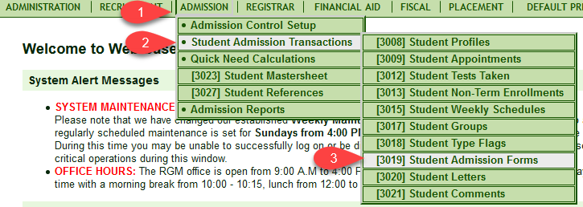

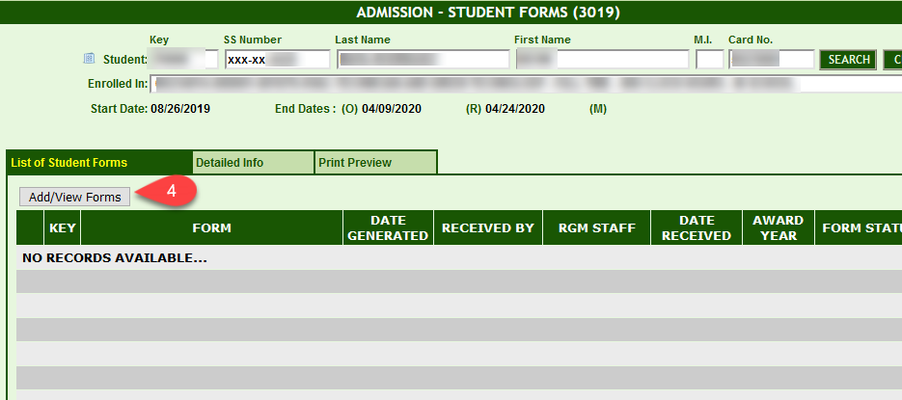

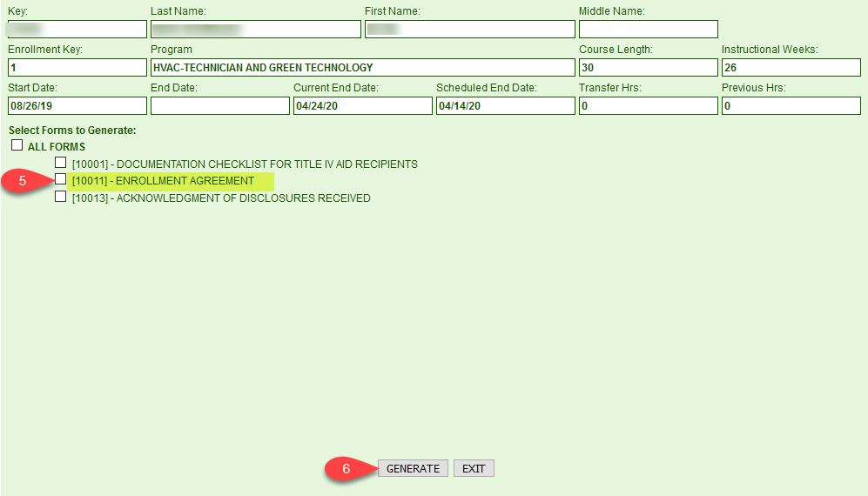

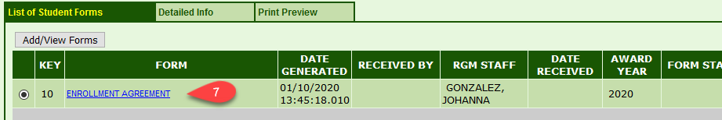

FOR REFERENCE ONLY***** FOR REFERENCE ONLY***** FOR REFERENCE ONLY***** FOR REFERENCE ONLY
Including California State Code (#) [10012] ENROLLMENT AGREEMENT
(4)  (5 a.) | School’s Name  «schlname» |  | Address where training will be provided  «schlstreet»  «schlcity», «schlstate» «schlzip»
Student Name |  |  |  | Last 4 digits of SSN.

Student Street Address | City | State | Zip Code

(4) Course Name: _________________________________________________ CIP code # _______ SOC Code # __________

Certificate ___ Diploma____ Course of ______ Semester OR _______ Quarter Credit hours AND/OR ______ Clock Hours

Course description:

Graduation Requirements:
Enrollment: | Cr/Clock Hrs. in Course |  | Transferred  Hours |  | Hours  Enrolled |  | Cancellation  Date
(5 c.) | Start Date |  | Expected  End Date |  | Instructional Weeks # |  | On-time Graduation date. See Note
Note: On time Graduation date includes a grace period of ____additional calendar days to complete the course. Additional training time beyond this date will cost the student $ _____ per _______ needed. These charges would not be covered by Title IV Financial aid.
Initials ______________ (5 b.) The period covered by this Enrollment Agreement is from ________ to ____________.
Enrollment Status: Full time ¾ time ½ time Less than ½ time Part time
Class Schedule: | Sunday | Monday | Tuesday | Wednesday | Thursday | Friday | Saturday | Total Hours per Week
Daily Hours
(6) (7)
((6)1-12) Itemized Charges By Payment Period | 1st Payment Period | 2nd Payment  Period | 3rd Payment  Period |  | 4th Payment Period |  | Total Course  Institutional Charges
Tuition (6(e)1)
Fees (Non-Refundable) (6(e)2)
Supplies (Non-Refundable) (6 (e)3,4,5,6)
OtherCharges(Non-Refundable)(6(e)8,9,10,12) (6(f)
STRF (Non-Refundable) (6 (e)11)(7)
Total Estimated Charges
TOTAL CHARGES FOR THE CURRENT PERIOD OF ATTENDANCE. (8) ___________
ESTIMATED TOTAL CHARGES FOR THE ENTIRE EDUCATIONAL PROGRAM. (8) ___________
TOTAL CHARGES THE STUDENT IS OBLIGATED TO PAY UPON ENROLLMENT.(8) ___________
Estimated Payments:
FPell Grant
FSEOG
Subsidized (NET LOAN)
Unsubsidized (NET LOAN)
PLUS (NET LOAN)
Cash
Other
Total Estimated payments
(15)(1) “Prior to signing this enrollment agreement, you must be given a catalog or brochure and a School Performance Fact Sheet, which you are encouraged to review prior to signing this agreement. These documents contain important policies and performance data for this institution. This institution is required to have you sign and date the information included in the School Performance Fact Sheet relating to completion rates, placement rates, license examination passage rates, and salaries or wages and the most recent three-year cohort default rate, if applicable, prior to signing this agreement”. (15)(2)Student Initials___________ “I certify that I have received the catalog, School Performance Fact Sheet, and information regarding completion rates, placement rates, license examination passage rates, and salary or wage information, and the most recent three-year cohort default rate, if applicable, included in the School Performance Fact sheet, and have signed, initialed, and dated the information provided in the School Performance Fact Sheet”. (18) I understand that this is a legally binding contract. My signature below certifies that I have read, understood, and agreed to my rights and responsibilities, and that the institution's cancellation and refund policies have been clearly explained to me.
(11) If I accept a student loan I will be responsible to repay the full amount of the loan plus interest, less any amount of any refund.
 | Student Signature: (16) | Guarantor’s Signature: | Institutional Representative signature: (16)
 | Printed Name: | Printed Name: | Printed name and Title:
 | Date: | Date: | Date:
(17) This enrollment agreement is a legally binding document when signed by the student and accepted by the institution. (14-1) Any questions a student may have regarding this enrollment agreement that have not been satisfactorily answered by the institution may be directed to the Bureau for Private Postsecondary Education at 1747 North Market, Suite 225, Sacramento, CA 95834, www.bppe.ca.gov, toll-free telephone number (888) 370-7589 or by fax (916) 263-1897. (14) A student or any member of the public may file a complaint about this institution with the Bureau for Private Postsecondary Education by calling (888) 370-7589 toll free or by completing a complaint form, which can be obtained on the bureau's internet web site www.bppe.ca.gov. Page 1 of 4
[10012] ENROLLMENT AGREEMENT

All charges stated on page one of this agreement are due and payable prior to the completion of each payment period.
The Title IV aid stated on page one of this agreement are only estimates depending on your eligibility for funds.
Student remains responsible for all incurred charges.
A monthly payment plan has been arranged for you. The plan is to make ____ payments due on the first of each month for the monthly amount of $ _______ and a final payment of $ _________.
Equipment received and accepted by the student is NOT REFUNDABLE.
You are responsible for the total amount of charges stated on page one of this enrollment agreement.
As stated on page one after the on time graduation date, the student will be responsible for additional tuition needed to complete the course by hour or per week. There will be no Financial Aid available for this period.

Course Description:

Graduation Requirement:

(5 (d)(10-1) STUDENT’S RIGHT TO CANCEL: The student has the right to cancel the enrollment agreement and obtain a refund of charges paid through attendance at the first class session (first day of classes), or the seventh day after enrollment (seven days from date when enrollment agreement was signed), whichever is later.

(10-3) The notice of cancellation shall be in writing and submitted directly to the Financial Aid Office, a withdrawal may be initiated by the student’s written notice or by the institution due to student’s academics or conduct, including, but not necessarily limited to, a student’s lack of attendance.

(10-2) Refund Policy: After the cancellation period, the institution provides a pro rata refund of ALL funds paid for tuition charges to students who have completed 60 percent or less of the period of attendance. Once more then 60 percent of the enrollment period in the entire course has elapsed (including absences), there will be no refund to the student. If the student has received federal student financial aid fund, the student is entitled to a refund of moneys not paid from federal student financial aid program funds.

A registration fee of $ ________ is a non-refundable item. Equipment, books, supplies, tools, uniforms, kits and any other items issued and received by the student would not be returnable. Once received by the student it will belong to the student and will represent a liability to the student.

If you cancel the agreement, the school will refund any money that you paid, less any deduction for registration fee and equipment received. If you withdraw from school after the cancellation period, the refund policy described above will apply. If the amount that you have paid is more than the amount that you owe for the time you attended, then a refund will be made within 45 days of the official withdrawal date. See Refunds section below. If the amount that you owe is more than the amount that you have already paid, then you will have to arrange with the institution to pay that balance. Official withdrawal date is on the student’s notification or school’s determination.

Determination of withdrawal from school: The withdrawal date shall be the last date of recorded attendance. The student would be determined to have withdrawn from school on the earliest of:
The date you notify the Financial Aid Office of your intent to withdraw. Only the Financial Aid Office would be authorized to accept a notification of your intent to withdraw.
The date the school terminates your enrollment due to academic failure or for violation of its rules and policies stated in the catalog.
The date you fail to attend classes for a two-week period and fail to inform the school that you are not withdrawing.
The date you failed to return as scheduled from an approved leave of absence. The withdrawal date shall be the last date of recorded attendance. The date of the determnation of withdrawal will be the scheduled date of return from LOA.
Return of Title IV: Special note to students receiving Unsubsidized/Subsidized/PLUS/Perkins loans, ACG/National SMART/Pell/SEOG grants or other aid, if you withdraw from school prior to the completion of the equivalent to 60 percent of the workload in any given payment period, a calculation using the percentage completed will be applied to the funds received or that could have been receive that will determine the amount of aid the student earned. Unearned funds would be returned to the program in the order stated below by the school and/or the student. Student liability to loan funds will continue to be paid in accordance to the original promissory note terms. Funds owed by the student to the Grant programs are limited to 50% of the gross award per program received. Sample Calculation, completion of 25% of the payment period or enrollment period earns only 25% of the aid disbursed or that could have been disbursed. If applicable, this would be the first calculation to determine the amount of aid that the student would be eligible for from the Title IV Financial Aid programs. A second calculation would take place to determine the amount earned by the institution during the period of enrollment. (12) If the student is eligible for a loan guaranteed by the federal or state government and the student defaults on the loan, both of the following may occur: (1) The federal or state government or a loan guarantee agency may take action against the student, including applying any income tax refund to which the person is entitled, to reduce the balance owed on the loan. (2) The student may not be eligible for any other federal student financial aid at another institution or other government assistance until the loan is repaid.

Student initial’s _______________
Page 2 of 4

[10012] ENROLLMENT AGREEMENT Page 3

(9) Student Tuition Recovery Fund: (STRF): 5, CCR §76215 (a)
“The State of California established the Student Tuition Recovery Fund (STRF) to relieve or mitigate economic loss suffered by a student in an educational program at a qualifying institution, who is or was a California resident while enrolled, or was enrolled in a residency program, if the student enrolled in the institution, prepaid tuition, and suffered an economic loss. Unless relieved of the obligation to do so, you must pay the state-imposed assessment for the STRF, or it must be paid on your behalf, if you are a student in an educational program, who is a California resident, or are enrolled in a residency program, and prepay all or part of your tuition.
You are not eligible for protection from the STRF and you are not required to pay the STRF assessment, if you are not a California resident, or are not enrolled in a residency program.”
“It is important that you keep copies of your enrollment agreement, financial aid documents, receipts, or any other information that documents the amount paid to the school. Questions regarding the STRF may be directed to the Bureau for Private Postsecondary Education, 1747 North Market, Suite 225 Sacramento, CA 95834, (916) 574-8900 or (888) 370-7589.
To be eligible for STRF, you must be a California resident or are enrolled in a residency program, prepaid tuition, paid or deemed to have paid the STRF assessment, and suffered an economic loss as a result of any of the following:
1. The institution, a location of the institution, or an educational program offered by the institution was closed or discontinued, and you did not choose to participate in a teach-out plan approved by the Bureau or did not complete a chosen teach-out plan approved by the Bureau.
2. You were enrolled at an institution or a location of the institution within the 120 day period before the closure of the institution or location of the institution, or were enrolled in an educational program within the 120 day period before the program was discontinued.
3. You were enrolled at an institution or a location of the institution more than 120 days before the closure of the institution or location of the institution, in an educational program offered by the institution as to which the Bureau determined there was a significant decline in the quality or value of the program more than 120 days before closure.
4. The institution has been ordered to pay a refund by the Bureau but has failed to do so.
5. The institution has failed to pay or reimburse loan proceeds under a federal student loan program as required by law, or has failed to pay or reimburse proceeds received by the institution in excess of tuition and other costs.
6. You have been awarded restitution, a refund, or other monetary award by an arbitrator or court, based on a violation of this chapter by an institution or representative of an institution, but have been unable to collect the award from the institution.
7. You sought legal counsel that resulted in the cancellation of one or more of your student loans and have an invoice for services rendered and evidence of the cancellation of the student loan or loans.
To qualify for STRF reimbursement, the application must be received within four (4) years from the date of the action or event that made the student eligible for recovery from STRF.
A student whose loan is revived by a loan holder or debt collector after a period of noncollection may, at any time, file a written application for recovery from STRF for the debt that would have otherwise been eligible for recovery. If it has been more than four (4) years since the action or event that made the student eligible, the student must have filed a written application for recovery within the original four (4) year period, unless the period has been extended by another act of law.
However, no claim can be paid to any student without a social security number or a taxpayer identification number.”

Refunds: If any refunds are due based on the Return of Title IV calculation or based on the institutional refund policy calculation, any refunds will be made as soon as possible but not later than 45 days from the determination of withdrawal date in the order stated in section CFR 34 section 668.22. The order of payment of refunds is, 1) Unsubsidized Loans from FFELP or Direct Loan, 2) Subsidized Loans from FFELP or Direct Loan, 3) Perkins Loans, 4) PLUS (Graduate Students) FFELP or Direct Loan, 5) PLUS (Parent) FFELP or Direct Loan, 6) Pell Grant, 7) Academic Competitiveness Grant (ACG), 8) National SMART Grant, 9) Federal SEOG, 10) Other. This order would apply in accordance to the aid programs available at the institution.
Course Cancellation: If a course is cancelled subsequent to a student’s enrollment and before instruction in the course has begun, the school shall at its option: 1) Provide a full refund of all money paid; or 2) Provide for completion of the course at schools in the neighborhood.
School Closure: If the school closes subsequent to a student’s enrollment and before instruction in the course has begun, the school shall at its option: 1) Provide a full refund of all money paid; or 2) Provide for completion of the course at schools in the neighborhood.

(13) NOTICE CONCERNING TRANSFERABILITY OF CREDITS AND CREDENTIALS EARNED AT OUR INSTITUTION: The transferability of credits you earn at «schlname» is at the complete discretion of an institution to which you may seek to transfer. Acceptance of the (degree, diploma, or certificate) you earn in (name of educational program*), is also at the complete discretion of the institution to which you may seek to transfer. If the (credits or degree, diploma, or certificate) that you earn at this institution are not accepted at the institution to which you seek to transfer, you may be required to repeat some or all of your coursework at the institution you are transferring. For this reason, you should make certain that your attendance at this institution will meet your educational goals. This may include contacting an institution to which you may seek to transfer after attending «schlname» to determine if your (credits or degree, diploma or certificate) will transfer.
*If institution offers more than one educational program, only the program in which the student is enrolling must be listed.

Note: Academic transcripts will not be released until tuition charges are paid in full.

Placement: This school does not guarantee placement. However, limited job placement assistance by providing referrals to graduates is available.

[10012] ENROLLMENT AGREEMENT

ANY DISPUTE ARISING FROM ENROLLMENT AT «schlname» NO MATTER HOW PLEADED OR STYLED, SHALL BE RESOLVED BY BINDING ARBITRATION UNDER THE FEDERAL ARBITRATION ACT CONDUCTED BY THE AMERICAN ARBITRATION ASSOCIATION (“AAA”), AT «schlcity», «schlstate» UNDER ITS COMMERCIAL RULES. THE AWARD RENDERED BY THE ARBITRATOR MAY BE ENTERED IN ANY COURT HAVING JURISDICTION. ANY HOLDER OF THIS CONSUMER CREDIT CONTRACT IS SUBJECT TO ALL CLAIMS AND DEFENSE WHICH THE DEBTOR COULD ASSERT AGAINST THE SELLER OF GOODS OR SERVICES OBTAINED PURSUANT HERETO OR WITH THE PROCEEDS HEREOF. RECOVERY THEREUNDER BY THE DEBTOR SHALL NOT EXCEED AMOUNTS PAID BY THE DEBTOR THEREUNDER.

Student understandings: I understand this agreement is not operative until I attend the first class or session of instruction. This requirement is not applicable to correspondence or other distance learning programs. I further understand that the catalog and its contents are a part of this enrollment agreement and that information presented therein is binding on the school and me.

My signature below certifies that I have read, understood and agreed to my rights and responsibilities, and that the institution’s cancellation and refund policies have been clearly explained to me.

I have read and understood this agreement which consists of 4 pages.

Student’s signature _________________________________________ Date _________

Page 4 of 4
Items not included in the agreement

Item#1 – CEC §94906 (a)(b)
(a) An enrollment agreement shall be written in language that is easily understood. If English is not the student's primary language, and the student is unable to understand the terms and conditions of the enrollment agreement, the student shall have the right to obtain a clear explanation of the terms and conditions and all cancellation and refund policies in his or her primary language.
(b) If the recruitment leading to enrollment was conducted in a language other than English, the enrollment agreement, disclosures, and statements shall be in that language.

Item#2 – CEC §94907 An enrollment agreement shall not contain a provision that requires a student to invoke an internal institutional dispute procedure before enforcing any contractual or other legal rights or remedies.
Item#3 – CEC §94908 Any information or statement required by this article to be included in the catalog, School Performance Fact Sheet, or enrollment agreement shall be printed in at least the same size font as the majority of the text in that document.
Item #19- CEC §94916-An Institution extending credit or lending money to an individual for institutional and non-institutional charges for an educational program shall cause any note, instrument, or other evidence of indebtedness taken in connection with that extension of credit or loan to be conspicuously marked on its face in at least 12-point type with the following notice:
“NOTICE”
“YOU MAY ASSERT AGAINST THE HOLDER OF THE PROMISSORY NOTE YOU SIGNED IN ORDER TO FINANCE THE COST OF THE EDUCATIONAL PROGRAM ALL OF THE CLAIMS AND DEFENSES THAT YOU COULD ASSERT AGAINST THIS INSTITUTION, UP TO THE AMOUNT YOU HAVE ALREADY PAID UNDER THE PROMISSORY NOTE.”

Distance education

Item #20 – 5 CCR §71716(a) An institution offering a distance educational program where the instruction is not offered in real time shall transmit the first lesson and any materials to any student within seven days after the institution accepts the student for admission.
Item #21 – 5 CCR §71716(b) The student shall have the right to cancel the agreement and receive a full refund pursuant to section 71750 before the first lesson and materials are received. Cancellation is effective on the date written notice of cancellation is sent. The institution shall make the refund pursuant to section 71750. If the institution sent the first lesson and materials before an effective cancellation notice was received, the institution shall make a refund within 45 days after the student’s return of the materials.
Item #22 – 5 CCR §71716 (c)(1) An institution shall transmit all of the lessons and other materials to the student if the student: (A) has
Fully paid for the educational program; and (B) after having received the first lesson and initial materials, request in writing that all of the materials be sent.
(2) If an institution transmits the balance of the material as the student requests, the institution shall remain obligated to provide the other educational services it agreed to provide, such as responses to student inquiries, student and faculty interaction, and evaluation and comment on lessons submitted by the student, but shall not be obligated to pay any refund after all of the lessons and material are transmitted.
Item #23 – For institutions offering a distance educational program where the instruction is not offered in real time, the enrollment agreement shall disclose the institution’s and students’ rights and duties under 5, CCR §71716 (a)(b)(c).
5,CCR §71716(d)

Complete Code CHECKlist on compliance visitation from California BPPE (Revised december, 2014)

NOTE: This document is meant to assist an institution in identifying applicable statutory requirements set forth in the California Private Postsecondary Education Act of 2009, and its regulations. Statutory and regulatory requirements may change, and such changes may not be reflected in this attachment. All persons approved to operate an institution are responsible for complying with all applicable requirements, whether or not reflected here.
Item#1 – CEC §94906 (a) An enrollment agreement shall be written in language that is easily understood. If English is not the student's primary language, and the student is unable to understand the terms and conditions of the enrollment agreement, the student shall have the right to obtain a clear explanation of the terms and conditions and all cancellation and refund policies in his or her primary language.
(b) If the recruitment leading to enrollment was conducted in a language other than English, the enrollment agreement, disclosures, and statements shall be in that language.
Item#2 – CEC §94907 An enrollment agreement shall not contain a provision that requires a student to invoke an internal institutional dispute procedure before enforcing any contractual or other legal rights or remedies.
Item#3 – CEC §94908 Any information or statement required by this article to be included in the catalog, School Performance Fact Sheet, or enrollment agreement shall be printed in at least the same size font as the majority of the text in that document.
Item #4 – CEC §94911(a) The name of the institution and the name of the educational program, including the total number of credit hours, clock hours, or other increment required to complete the educational program.
Item #5—(5, CCR §71800(a) through (d)-The enrollment agreement shall contain the following: (a)The name and address of the institution and the addresses where instruction will be provided. (b) Period covered by the enrollment agreement. (c) Program start date and scheduled completion date. (d) The date by which the student must exercise his or her right to cancel or withdraw, and the refund policy.
Item #6 (e) Itemization of all institutional charges and fees including, as applicable:
(1) tuition;
(2) registration fee (non‐refundable);
(3) equipment;
(4) lab supplies or kits;
(5) Textbooks, or other learning media;
(6) uniforms or other special protective clothing;
(7) On resident housing;
(8) tutoring;
(9) assessment fees for transfer of credits;
(10) fees to transfer credits;
(11) Student Tuition Recovery Fund fee (non‐refundable);
(12) any other institutional charge or fee.
(f) Charges paid to an entity other than in institution that is specifically required for participation in the educational program.
(5, CCR §71800 (e)through (f)
Item#7 – CEC §94911(b) A schedule of total charges, including a list of any charges that are nonrefundable and the student's obligations to the Student Tuition Recovery Fund, clearly identified as nonrefundable charges.
Item#8 – CEC §94911 (c) In underlined capital letters on the same page of the enrollment agreement in which the student's signature is required, the total charges for the current period of attendance, the estimated total charges for the entire educational program, and the total charges the student is obligated to pay upon enrollment.
Item #9 – 5, CCR §76215(a) A qualifying institution shall include the following statement on both its enrollment agreement for an educational program and its current schedule of student charges: “You must pay the state‐imposed assessment for the Student Tuition Recovery Fund (STRF) if all of the following applies to you:
You are a student in an educational program, who is a California resident, or are enrolled in a residency program, and prepay all of part of your tuition either by cash, guaranteed student loans, or personal loans, and
Your total charges are not paid by any third‐party payer such as an employer, government program or other payer unless you have a separate agreement to repay the third party. You are not eligible for protection from the STRF and you are not required to pay the STRF assessment if either of the following applies:
1. You are not a California resident, or are not enrolled in a residency program, or
2. Your total charges are paid by a third party, such as an employer, government program or other payer, and you have no separate agreement to repay the third party.”
5, CCR §76215(b) In addition to the statement described under subdivision (a) of this section, a qualifying institution shall include the following statement on its current schedule of student charges: “The State of California established the Student Tuition Recovery Fund (STRF) to relieve or mitigate economic loss suffered by a student in an educational program at a qualifying institution, who is or was a California resident while enrolled, or was enrolled in a residency program, if the student enrolled in the institution, prepaid tuition, and suffered an economic loss. Unless relieved of the obligation to do so, you must pay the state-imposed assessment for the STRF, or it must be paid on your behalf, if you are a student in an educational program, who is a California resident, or are enrolled in a residency program, and prepay all or part of your tuition.
You are not eligible for protection from the STRF and you are not required to pay the STRF assessment, if you are not a California resident, or are not enrolled in a residency program.”
Item#10– CEC §94911 (e)(1) A disclosure with a clear and conspicuous caption, "STUDENT'S RIGHT TO CANCEL," under which it is explained that the student has the right to cancel the enrollment agreement and obtain a refund of
charges paid through attendance at the first class session, or the seventh day after enrollment, whichever
is later.
(2) The disclosure shall contain the institution's refund policy and a statement that, if the student has received federal student financial aid funds, the student is entitled to a refund of moneys not paid from federal student financial aid program funds.
(3) The text shall also include a description of the procedures that a student is required to follow to cancel the enrollment agreement or withdraw from the institution and obtain a refund.
Item#11 – CEC §94911(f) A statement specifying that, if the student obtains a loan to pay for an educational program, the student will have the responsibility to repay the full amount of the loan plus interest, less the amount of any refund.
Item#12 – CEC §94911 (g) A statement specifying that, if the student is eligible for a loan guaranteed by the federal or state government and the student defaults on the loan, both of the following may occur:
(1) The federal or state government or a loan guarantee agency may take action against the student, including applying any income tax refund to which the person is entitled to reduce the balance owed on the loan.
(2) The student may not be eligible for any other federal student financial aid at another institution or other government assistance until the loan is repaid.
Item# 13– CEC §94911 (h) The transferability disclosure that it is required to be included in the school catalog, as specified in paragraph (15) of subdivision (a) of section 94909. CEC §94909
(a) Prior to enrollment, an institution shall provide a prospective student, either in writing or electronically, with a school catalog containing, at a minimum, all of the following:
(15) The following statement:
"NOTICE CONCERNING TRANSFERABILITY OF CREDITS AND CREDENTIALS EARNED AT OUR INSTITUTION"
"The transferability of credits you earn at (name of institution) is at the complete discretion of an institution to which you may seek to transfer. Acceptance of the (insert degree, diploma, or certificate) you earn in (insert name of educational program*) is also at the complete discretion of the institution to which you may seek to transfer. If the (insert credits or degree, diploma, or certificate) that you earn at this institution are not accepted at the institution to which you seek to transfer, you may be required to repeat some or all of your coursework at that institution. For this reason you should make certain that your attendance at this institution will meet your educational goals. This may include contacting an institution to which you may seek to transfer after attending (insert name of institution) to determine if your (insert credits or degree, diploma or certificate) will transfer."
*If institution offers more than one educational program, only the program in which the student is enrolling must be listed.
Item#14 – CEC §94911 (j) The following statements:
(1) "Any questions a student may have regarding this enrollment agreement that have not been satisfactorily answered by the institution may be directed to the Bureau for Private Postsecondary Education at 1747 North Market, Suite 225 Sacramento, CA 95834, P.O. Box 980818, West Sacramento, CA 95798-0818, www.bppe.ca.gov, toll‐free telephone number (888) 370‐7589 or (916) 574-8900 or by fax (916) 263‐1897."
(2) "A student or any member of the public may file a complaint about this institution with the Bureau for Private Postsecondary Education by calling (888) 370-7589 toll free or by completing a complaint form, which can be obtained on the bureau's internet web site www.bppe.ca.gov."
Item#15– CEC §94911(i)(1) "Prior to signing this enrollment agreement, you must be given a catalog or brochure and a School Performance Fact Sheet, which you are encouraged to review prior to signing this agreement. These documents contain important policies and performance data for this institution. This institution is required to have you sign and date the information included in the School Performance Fact Sheet relating to completion rates, placement rates, license examination passage rates, and salaries or wages, and the most recent three-year cohort default rate, if applicable, prior to signing this agreement."
(2) Immediately following the statement required by paragraph (1), a line for the student to initial, including the following statement: "I certify that I have received the catalog, School Performance Fact Sheet, and information regarding completion rates, placement rates, license examination passage rates, and salary or wage information, and the most recent three-year cohort rate, if applicable, included in the School Performance Fact sheet, and have signed, initialed, and dated the information provided in the School Performance Fact Sheet."
Item #16- A student shall enroll solely by means of executing an enrollment agreement. The enrollment agreement shall be signed by the student and by an authorized employee of the institution. (CEC §94902(a))
Item#17 – CEC §94911 (d) A clear and conspicuous statement that the enrollment agreement is legally binding when signed by the student and accepted by the institution.
Item#18 – CEC §94911 (k) The following statement above the space for the student's signature: "I understand that this is a legally binding contract. My signature below certifies that I have read, understood, and agreed to my rights and responsibilities, and that the institution's cancellation and refund policies have been clearly explained to me.”
Item #19-An institution extending credit or lending money to an individual for institutional and not institutional charges for an educational program shall cause any note, instrument, or other evidence of indebtedness taken in connection with that extension of credit or loan to be conspicuously marked on its face in at least 12-point type with the following notice: (CEC §94916) "NOTICE" "YOU MAY ASSERT AGAINST THE HOLDER OF THE PROMISSORY NOTE YOU SIGNED IN ORDER TO FINANCE THE COST OF THE EDUCATIONAL PROGRAM ALL OF THE CLAIMS AND DEFENSES THAT YOU COULD ASSERT AGAINST THIS INSTITUTION, UP TO THE AMOUNT YOU HAVE ALREADY PAID UNDER THE PROMISSORY NOTE." A note, instrument, or other evidence of indebtedness relating to payment for an educational program is not enforceable by an institution unless, at the time of execution of the note, instrument, or other evidence of indebtedness, the institution held an approval to operate. (CEC §94917) In making consumer loans to students, an institution shall also comply with the requirements of the Federal Truth in Lending Act pursuant to Title 15 of the United States Code. (CEC §94918)
Item #20 – 5,CCR §71716(a) An institution offering a distance educational program where the instruction is not offered in real time shall transmit the first lesson and any materials to any student within seven days after the institution accepts the student for admission
Item #21 – 5, CCR §71716(b) The student shall have the right to cancel the agreement and receive a full refund pursuant to section 71750 before the first lesson and materials are received. Cancellation is effective on the date written notice of cancellation is sent. The institution shall make the refund pursuant to section 71750. If the institution sent the first lesson and materials before an effective cancellation notice was received, the institution shall make a refund within 45 days after the student’s return of the materials.
Item #22 – 5, CCR §71716 (c)(1) An institution shall transmit all of the lessons and other materials to the student if the student: (A) has fully paid for the educational program; and (B) after having received the first lesson and initial materials request in writing that all of the material be sent.
(2) If an institution transmits the balance of the material as the student requests, the institution shall remain obligated to provide the other educational services it agreed to provide, such as responses to student inquiries, student and faculty interaction, and evaluation and comment on lessons submitted by the student, but shall not be obligated to pay any refund after all of the lessons and material are transmitted.
Item #23 – For institutions offering a distance educational program where the instruction is not offered in real time, the enrollment agreement shall disclose the institution’s and students’ rights and duties under 5, CCR §71716 (a)(b)(c).
5, CCR §71716(d)

BPPE REVISED DECEMBER, 2014

10013 ACKNOWLEDGMENT OF DISCLOSURES RECEIVED

This is not a required form

The form serves to retain a single record of the actions conducted by the institution prior to signing an enrollment agreement, at the time of signing the enrollment agreement and possibly in accordance to your institutional procedures, on the first day of class. The form was prepared based on requirements from multiple accrediting commissions and state agencies. Please review it very carefully and determine what does apply to your institution. If some of the forms cited on this list were added to the catalog, this single form which is initialized and signed by the student will document that the student received those forms and/or disclosures.

Status of this form: Provided Word.doc format for your use, this form is available to generate as a form by the RGM system. Go to Admission: Student Admission Transactions: Student Admission Forms transaction #3019. You click on Add/View Other Forms, you check the box with form [10013] and click the link, the form will then pop up.

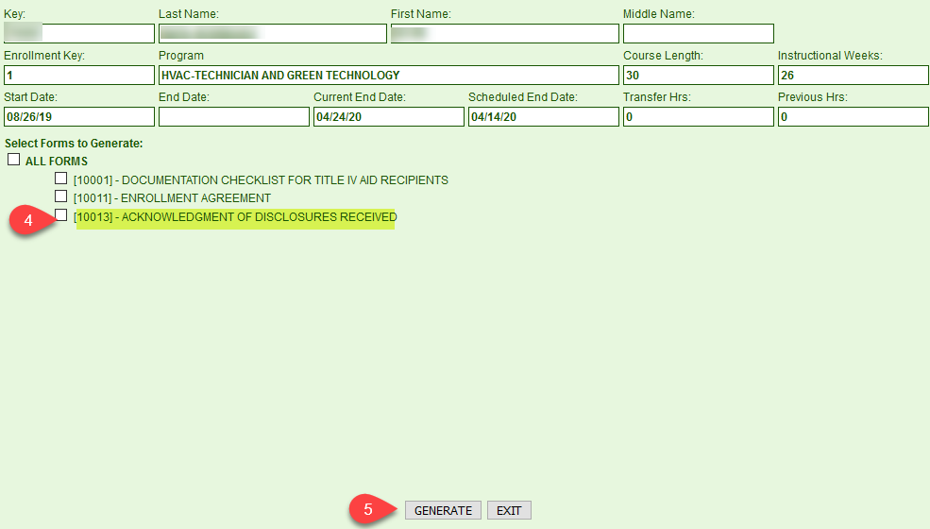

10015 PROFESSIONAL JUDGMENT (PJ) AND/OR DEPENDeNCY OVERRIDE (DO) WORKSHEET

This is NOT a required form, however, during program reviews, schools have been cited for not providing correct documentation as to WHERE THE STUDENT MAKES THE REQUEST AND, THE FAO DOCUMENTS in the student’s file the FAOs REASONS TO SUPPORT a PJ or D/O.

This form is a tool for the student and FAO to document the student special circumstances that merit the actions to be accepted and taken by the FAO.

REMEMBER: A STUDENT SELECTED FOR THE VERIFICATION PROCESS, FAO MUST COMPLETE THE VERIFICATION PROCESS BEFORE A PROFESSIONAL JUDGMENT MAY BE CONSIDERED BY THE INSTITUTION FOR APPROVAL.

Status of this form: Provided in Word.doc format for your use, this form can be generated as a form in the RGM system. It is under Financial Aid: Student Financial Aid Transactions: Student’s Financial Aid Forms transaction [5007]. When you select a student, you will click on Add/View Forms, the list of forms will generate, you will check the box for form [10015], you then click on the red link and the form will pop up.

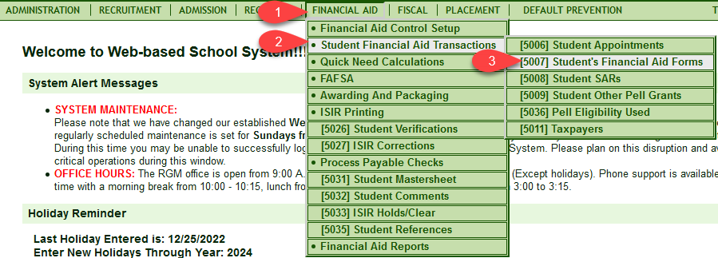

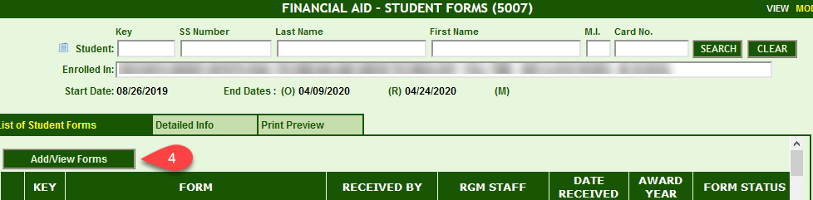

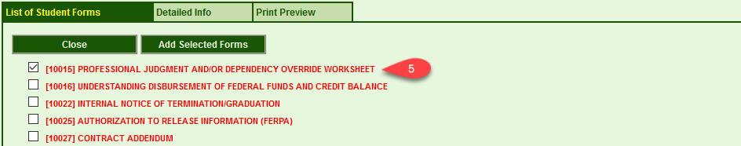

SPECIAL NOTE: The RGM system is been updated, as of March 1, 2016, the current manner to record the fact that the Verification process has been completed will be modified. FAOs must use the new format in the system that follows the student verification group and provides the list of elements to be verified. If the student used the data retrieval from the IRS and resulted in code 02, those items would not require verification. However the other items in the group would still require verification and changes. If changes are needed, a new ISIR would be generated and if the group number changes and a new verification group number is assigned, the ISIR new items to be verified.

10016 Understanding disbursement of federal funds and credit balance

This is NOT a required form. However, some of the actions stated on the form require the student’s acknowledgement and school documentation.

This form is a tool for the student and FAO to document the students’ acknowledgement of the authorization given by the student to credit his/her school account for tuition, fees and books and supplies with proceeds from SFA funds from grant and student loan programs.

Status of this form: Provided in Word.doc format for your use, this form can be generated as a form in the RGM system. It is under Financial Aid: Student Financial Aid Transactions: Student’s Financial Aid Forms transaction [5007]. When you select a student, you will click on Add/View Forms, the list of forms will generate, you will check the box for form [10016], you click on the red link and the form will pop up.

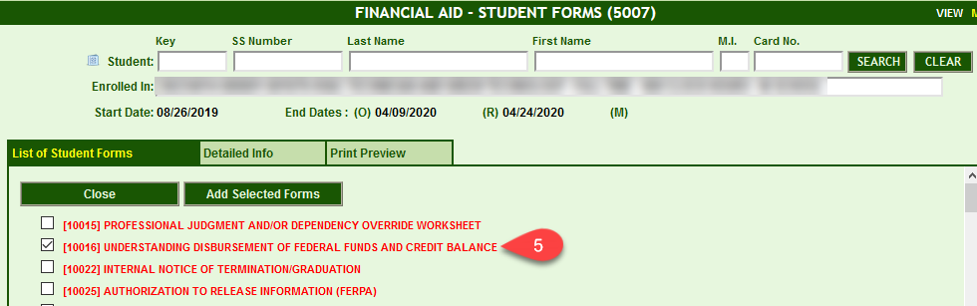

10017 Special selection of seog recipient

This is NOT a required form. This only applies if the award is NOT made within the schools’ written policy.

This form is a tool for the FAO to document the decision to grant an SEOG award outside of the institutional guidelines. SEOG is a grant designed to assist students with EXCEPTIONAL NEED, this student may be defined as students with an EFC of 0 (Zero), the funds must be available to the entire enrollment in the 12 months of the fiscal year. The institutional SEOG awarding policy must be clearly described in the annual institutional catalog. Any awards made out of the policy parameters must be thoroughly documented.

Status of this form: Provided in Word.doc format for your use, this form can be generated as a form in the RGM system.

10018 AdVISING AND/OR COUNSELING report

This is NOT a required form.

Most agencies, who oversee the school approvals, require that the institution retain records of any advising and/or counseling interviews with the student. This form could be used for documentation purposes.

Status of this form: Provided in Word.doc format for your use, this form will be generated as a form by the RGM system.
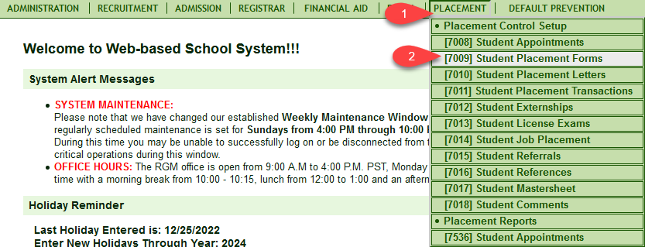

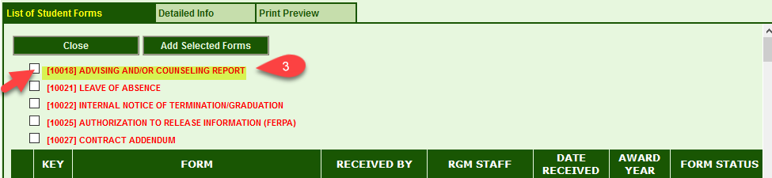

10019 FINANCIAL AID OFFICE REVIEW AND DISBURSEMENT APPROVAL CREDIT/CLOCK HOUR NON-TERM PROGRAMS

This is NOT a required form

All financial aid disbursements must be checked on a regular basis by the FAO for continuous eligibility. This form serves as a control of such activity by the FAO.

Institutions could use the RGM system under the Financial Aid Module: Financial Aid Reports: [5034] Financial Aid Reports, on the drop down select (5520) SAP notifications then you must enter a range of dates, then Generate Report, for any student not making SAP at the end of a Financial Aid Warning Status. You may also select from the dropdown report (5519) Financial SAP Report, under [5034] which would provide a list of students based on your selected criteria with a scheduled or actual SAP evaluation date. Additionally, under the Registrar Menu: Registrar Reports: [4506] Student Progress Reports, it will show the student SAP. You can also generate by multiple students and report will move to Batch Reports.

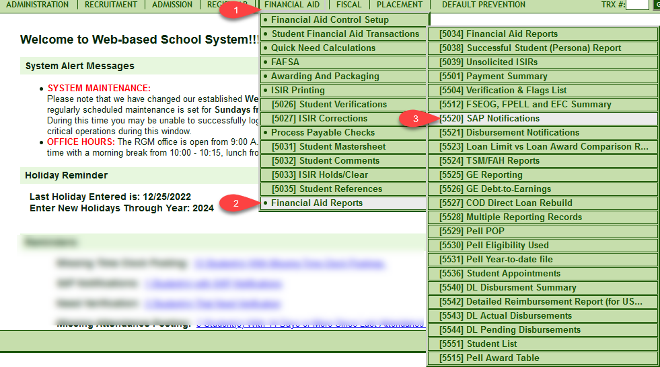

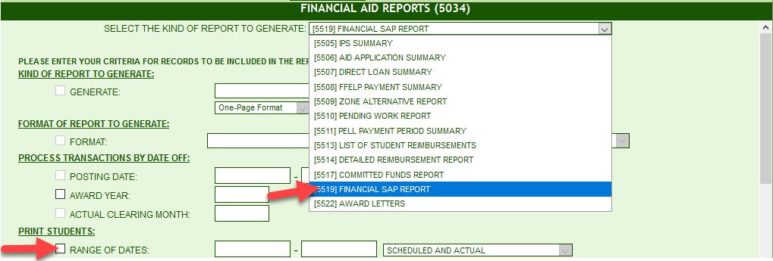

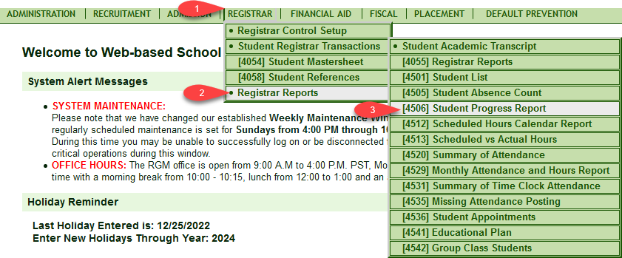

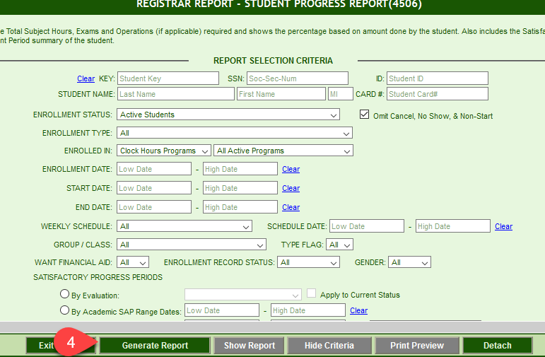

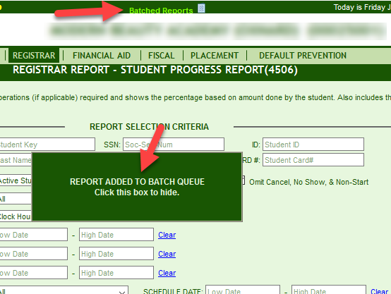

Status of this form: Provided in Word.doc format for your use, this form will be generated as a form by the RGM system.

10020 CREDIT BALANCES FORM

This is NOT a required form

Accurate packaging of aid would eliminate the need of a credit balance; however, there are circumstances which may arise where there will be a credit balance. If the student is to receive funds for personal expenses, they should coincide with school disbursements. If the disbursement of Title IV funds exceeds the current institutional charges assessed to the student tuition account, the school has 14 calendar days to disburse those excess funds. The form assists FAOs to keep track of the transaction.

IMPORTANT REMINDER FROM FSA HANDBOOK (2017-18) – Volume 4, Chapter 1, Page 4-19

An FSA credit balance occurs whenever your school credits FSA program funds to a student’s account and the total amount of those FSA funds exceeds the student’s allowable charges. Please see Volume 5 for a discussion of credit balances when a student withdraws.
If FSA disbursements to the student’s account at the school create an FSA credit balance, you must pay the credit balance directly to the student or parent as soon as possible but no later than 14 days after:
• the date the balance occurred on the student’s account, if the balance occurred after the first day of class of a payment period, or

• the first day of classes of the payment period if the credit balance occurred on or before the first day of class of that payment period.

Because FSA credit balance funds are funds that have already been disbursed, a school must pay an FSA credit balance to a student on a leave of absence

Status of this form: Provided in Word.doc format for your use, this form can be generated as a form by the RGM system. Under Fiscal: [6033] Student Fiscal Forms. After you enter the student, you click on Add/View Other Forms, the list of forms will show on the screen, you then check the box for the credit balance form [10020] and click the red letters, the form will generate.

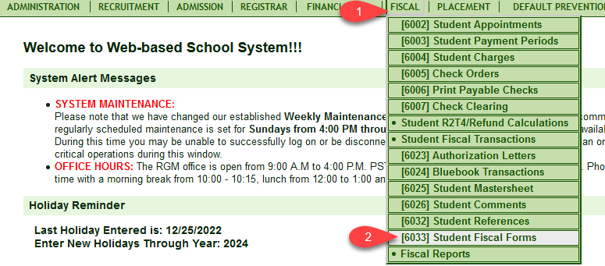

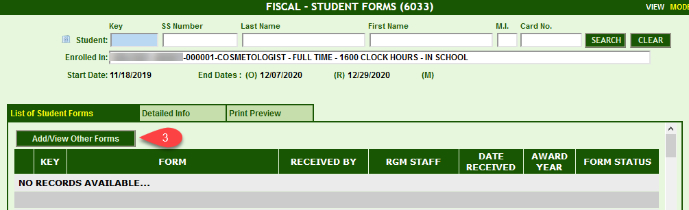

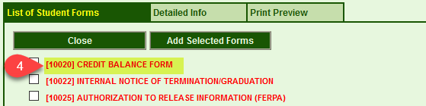

Additional comments on this form:

Credit balances is the number 7 finding in audits and number 3 in program reviews. Institutions must avoid and eliminate any possibility of credit balances by following this procedure.

1 Determine the institutional charges (tuition, fees, books and supplies charges for each academic year.

2 Determine how much living expenses the student will need during the same academic year (if any).

3 Package the student with all sources of aid for the combined total.

4 As funds are disbursed for school expenses the student living allowance must also be disbursed at the same time WITHIN 14 calendar days from the date the funds are received from G5.

5 Understand that the total of the tuition assessed to the first payment period will be fully covered during the disbursement of the second payment period in the academic year.

7 Maintain clear audit trail of all transactions

Credit balance form may not be used to obtain authorization to hold credit balance funds, for schools in Reimbursement, HCM1 or HCM2. You must pay the student out of own institutional funds, prior to requesting funds from G5 if on HCM1, or from Regional Office if on HCM2.

10021 LEAVE OF ABSENCE (LOA) request form

This is a required form

The institution is required to retain a written request for a LOA from the student and a written approval of the request by the institution. The use of this form helps in meeting the LOA written request requirement.

Please read the form for specific requirements that makes an LOA an approved process. This information will be transmitted electronically to NSLDS, in the required monthly enrollment reporting. It is critical that the new expected graduation date is modify in accordance to the approve LOA and just as critival is the recording of the return date from an LOA.

Status of this form: Provided in Word.doc format for your use, this form can be generated as a form in the RGM system. Under Registrar, Student Registrar Transactions: Student Registrar Forms. After selecting a student, you will click on Add/View Forms, the list of forms will generate, you will check the box for form [10021], you then click the red link and the form will pop up.

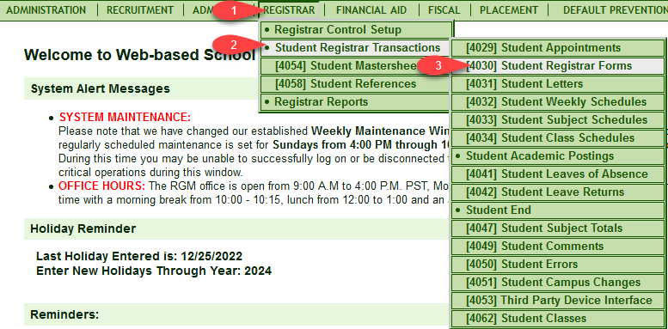

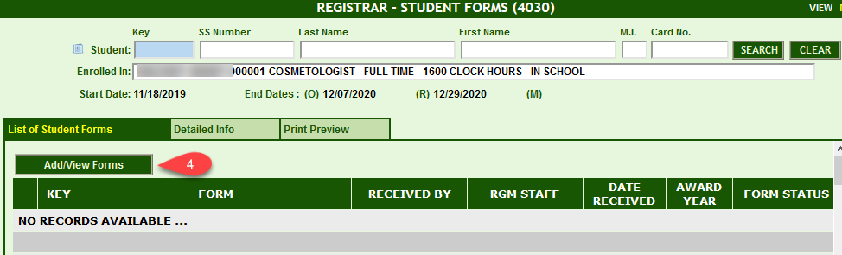

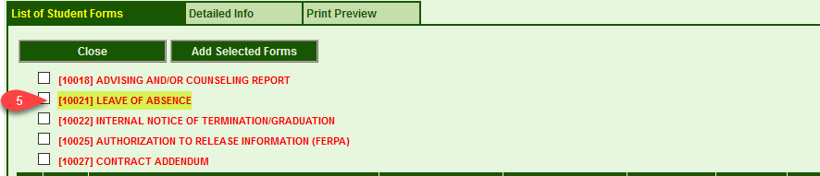

10022 INTERNAL NOTICE OF TERMINATION/graduation

This is NOT a required form

Most agencies, who oversee the school approvals, require that the institution maintain records of graduates and withdrawals. For withdrawals, each agency has its own accounting procedures for the withdrawal reasons. Internally, the staff needs to review their student status under their area of responsibilities to secure that the student is properly terminated. The use of this form will assist in tracking the approvals to release termination/graduation records and enrollment status of the student the registrar, financial aid and fiscal departments.

Status of this form: Provided in Word.doc format or your use, this form can be generated as a form in the RGM system. Under Fiscal: [6033] Student Fiscal Forms, after selecting the student, you will click on the Add/View Other Forms button, the list of forms will show, then you click the box next to form [10022] Internal Notice of Termination/Graduation and click the red letters, the form will generate.

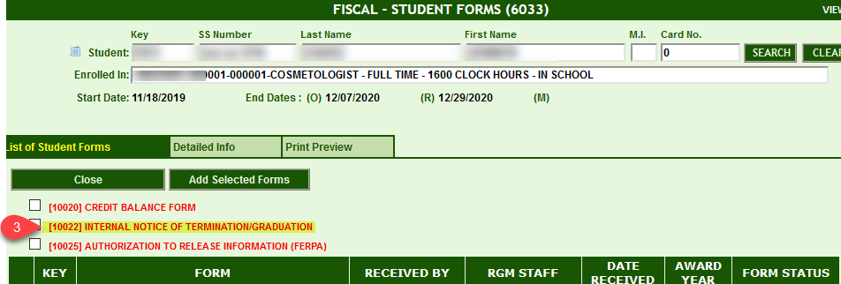

10023 EMPLOYMENT WAIVER

This is NOT a required form
special note to the institution regarding the utilization of the employment waiver form
The form is designed to document that a given student, though enrolling in a "vocational" course of study, was doing so with NO intent of seeking employment in the designated field after course completion. The presence or absence of this form in the file, however, has NO statutory, regulatory, policy or procedural bearing relative to the U.S. Department of Education, California Bureau for Private Postsecondary Education (BPPE) or your Accrediting Agency.

Status of this form: Provided in Word.doc format or your use, this form can be generated as a form in the RGM system. Under Placement: [7009] Student Placement Forms. After selecting the student, you will click on the Add/View Other Forms button, the list of forms will show, then you click the box next to form [10023] Employer Waiver and click the red letters, the form will generate.

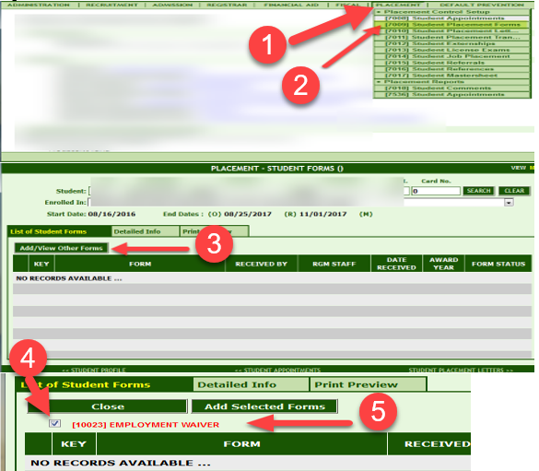

10024 STUDENT LOAN BORROWER REFERENCE TRACKING FORM

This is NOT a required form

This form is used to obtain references from the student that will assist later in your default prevention procedures. It has been recommended by loan collection agencies to get this data before the student enters school. Additionally, the data on this form has been very helpful in tracking students about placement tracking.

Status of this form: Provided in Word.doc format for your use, this form will not be generated as a form by the RGM system.

10025 RELEASE OF INFORMATION AUTHORIZATION FORM (FERPA)

This is a required form for ALL schools participating in ANY Title IV Federal Student Aid Program

This form is to protect the school against releasing information contained in the student file to any individual, or any out of state agency, accreditation agency, or federal agencies. Before data can be released to outside individuals, the school must protect itself by obtaining the student approval. Schools must have a written policy that relates to students and parents the institutional record retention procedure. On this form you will find the suggested policy. Each individual request must be protected with a single form. One form does not cover all request. Please complete this form ONLY at the time each request is made. Do not complete the form ahead of time.

Status of this form: Provided in Word.doc format for your use, this form can be generated as a form in the RGM system. Under the Registrar, Financial Aid and Fiscal menu. Under the Registrar: Student Registrar Transactions: Student Registrar Forms, transaction [4030]. Once you select the student you click on Add/View Forms, then check the box for form [10025], you then click the red link and the form will pop up. Under the Financial Aid: Student Financial Aid Transactions: Students Financial Aid Forms transaction [5007]. Once you select the student you click on Add/View Forms, the list of forms will generate and you will click the box for form [10025], you then click the red link and the form will pop up. Under Fiscal: Student Fiscal Forms transaction [6033]. You select a student then click on Add/View Other Forms, the list of forms will generate, you then check the box for form [10025], you then click the red link and the form will pop up

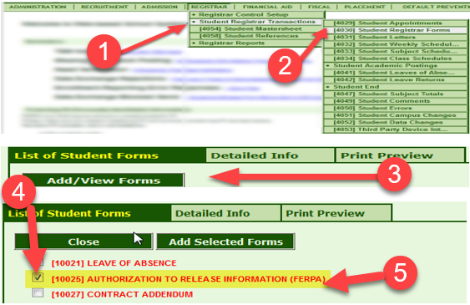

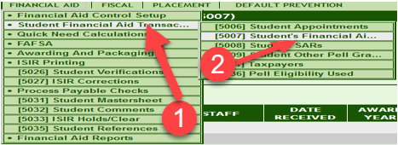

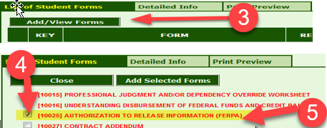

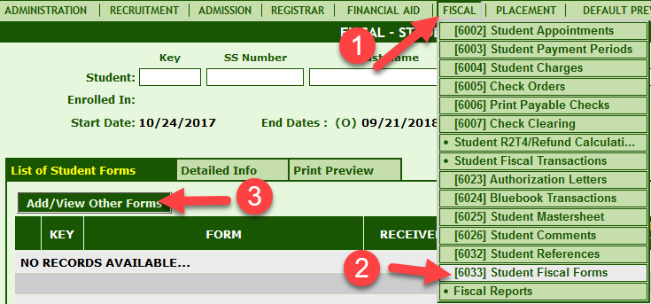

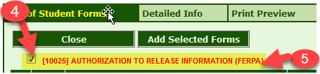

10027 CONTRACT ADDENDUM

This is NOT a required form

This form tracks the changes made to the original enrollment agreement when student changes programs or weekly/attendance schedules.

Status of this form: Provided in Word.doc format for your use, this form can be generated as a form in the RGM system. Under the Registrar and Financial aid menu. Under the Registrar: Student Registrar Transactions: Student Registrar Forms, transaction [4030]. When you select the student, you will click on Add/View Forms, the list of forms will generate, you will check the box for form [10027], you will then click the red link and the form will pop up. Under the Financial Aid: Student Financial Aid Transactions, transaction [5007]. When you select the student, you will click on Add/View Forms, the list of forms will generate, you will check the box for form [10027], you will then click the red link and the form will pop up.

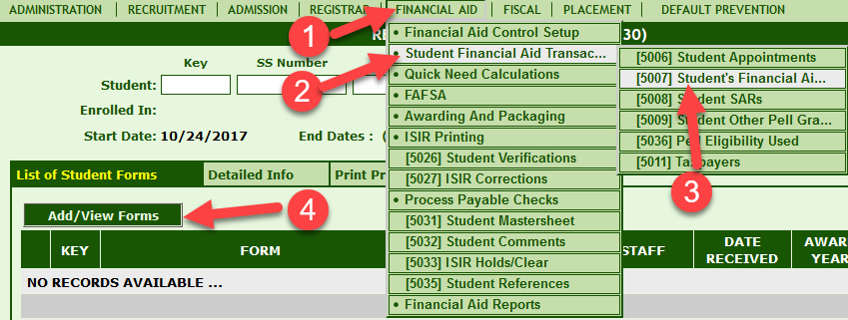

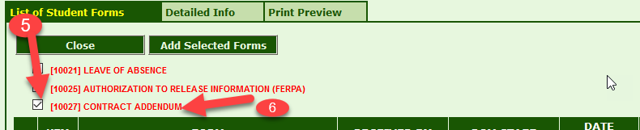

10028 INSTITUTIONAL RECORD OF ADMISSION APPLICATIONS

This is NOT a required form

This form is used to assist the financial aid staff in determining the student admission status. RGM recommends the implementation of this form, as required by some accrediting agencies, to indicate whether the student was admitted or rejected for enrollment.

10029 Sample Employee Verification Form
This is not a required form, however accrediting commissions and State agencies may require institutions to provide documentation from employers about placement rates.

10029 Sample Employment Verification Form
(To be completed by the employer)

Employee / Graduate Information
Name
Job Title
Job Start Date
Job End Date
Starting Salary
Number of Hrs. Per Week
Employer’s Information
Company’s Name
Company’s Address
Company’s Phone Number
Company’s Email
Supervisor’s Information
Name
Job Title
Print Name
Signature
Confirmation Data
Confirmed by
Signature
Date

Sample Self-Employment Certification

I, ______________________ certify that I am currently self-employed as a __________________, and have been since ___________________.
I may be contacted at the following phone number: ___________________
The name of my business is: ___________________
I certify that my ___________________ (driver’s license, state ID card, etc.) was present at the time of signing this document.

______________________________________ ___________________
Student Signature Date

______________________________________ ___________________
School Official’s Signature Date

[Attach Verification]

EMPLOYMENT ASSISTANCE WAIVER

The education I have received has prepared me for employment in my field of study. At this time assistance in obtaining employment is declined for the following reason:

(Initial as applicable.)
________ Continuing Education*

School Name: ________________________________________________________

Address, City, State: ___________________________________________________

Program / Area of Study: _______________________________________________

Start Date: ___________________________________________________________

________ International Student – Visa Restriction**

________ Active Military* *

________ Death**

________ Incarceration**

Initial and attach documentation, as applicable.
_____________________________________________ ________________________________
Graduate Name (Print) Program

_____________________________________________ ________________________________
Graduate / Authorized Signature Date

SELF-EMPLOYMENT STATEMENT

The education I have received has prepared me for employment in my field of study. At this time it fulfills my employment objective to be self-employed. Self-employment meets my vocational and monetary objectives.

Contact Information

Address: __________________________________________________________________________

City: _____________________________ State: ______________________ Zip: ______________

Home Phone: ____________________________ Cell Phone: __________________________

Email: _____________________________________________________________________________

_____________________________________________ _______________________________
Program Graduation Date

Attachment documentation to support self-employment.

_____________________________________________ ______________________________
Name of Person Verifying Information (Print) Title

_____________________________________________ ______________________________
Signature Date

PART-TIME EMPLOYMENT STATEMENT

The education I have received from has prepared me for employment in my field of study. It fulfills my employment objective to work part-time as evidenced by my signature below and acceptance of such employment. Part-time employment meets my vocational and monetary objectives.

_____________________________________________ ________________________________
Graduate’s Name (Print) Graduation Date

_____________________________________________
Program

_____________________________________________ ________________________________
Graduate Signature Date

CONTINUING EMPLOYMENT STATEMENT

The education I have received has prepared me for employment. At this time it fulfills my employment objective to continuing employment at my current employer, who was my employer at the time of enrollment in the education program. Continuing my employment at my current employer meets my vocational and monetary objectives.

As a result of the education I have received a:
(Initial one or more, as applicable.)

________ Promotion

________ Increase in Responsibility

________ Salary Increase

- Or -

________ I was required to complete the training as a condition of continued employment.

________ Attached is documentation of potential advancement with my current employer in my field of study.

_____________________________________________ ________________________________
Graduate’s Name (Print) Graduation Date

_____________________________________________
Program

_____________________________________________ ________________________________
Graduate’s Signature Date

[10001] Documentation checklist Ufor Title IV Aid recipients
«schlname» «sssscc»
«schlstreet» - «schlcity», «schlstate» «schlzip»

Student Name: _______________________________________ Student Key No. ______________
Admissions: | N/A | Req | Pen | CC |  | FWS: | N/A | Req | Pen | CC
Enrollment Application (RGM) |  |  |  |  |  | WS - Job Description
Prior Education: | N/A | Req | Pen | CC |  | WS - Class Schedule
U.S. High School Grad or equivalent |  |  |  |  |  | WS - Work schedule
College Academic Transcripts |  |  |  |  |  | WS - Off- campus contract
Ability to Benefit student |  |  |  |  |  | WS - Time Card
Documentation of Eligibility |  |  |  |  |  | WS - Supervisor Certification
Acceptance documentation |  |  |  |  |  | WS - Payroll Record
Consumer Information: (in Catalog) | N/A | Req | Pen | CC |  | SAP: | N/A | Req | Pen | CC
Student right to know |  |  |  |  |  | Advising and/or Counseling
Crime Statistics |  |  |  |  |  | SAP Evaluation
Drug Free Workplace |  |  |  |  |  | FAO SAP Certification
Admissions Disclosure Form |  |  |  |  |  | Fiscal: | N/A | Req | Pen | CC
Gainful Employment Disclosure |  |  |  |  |  | Ledger Card
California State Disclosures: | N/A | Req | Pen | CC |  | Record of aid checks disbursed
Current Catalog (In Web site) |  |  |  |  |  | Credit Balance Form and resolution
School Performance Fact Sheet (*) |  |  |  |  |  | Leave Of Absence: | N/A | Req | Pen | CC
Enrollment Agreement (*) |  |  |  |  |  | LOA request and approval
Registrar: | N/A | Req | Pen | CC |  | Record of LOA return
Academic record |  |  |  |  |  | Termination: | N/A | Req | Pen | CC
Financial Aid: | N/A | Req | Pen | CC |  | Loan exit interviews
FAFSA |  |  |  |  |  | Internal Notice of Termination
ISIR |  |  |  |  |  | Return of Title IV and Refund Calc. | N/A | Req | Pen | CC
Verification: | N/A | Req | Pen | CC |  | R2T4 Calculation form
Verification tracking form |  |  |  |  |  | Refund Calculation form (Ref Paid doc.)
Verification ID documentation |  |  |  |  |  | Post-withdrawal Notification
Student/Spouse Tax |  |  |  |  |  | Post-withdrawal Resolution
Parents tax forms |  |  |  |  |  | Notice to Private Lenders
Professional Judgment and D/O: | N/A | Req | Pen | CC |  | License Exam: | N/A | Req | Pen | CC
Prof Judgment Worksheet and D/O |  |  |  |  |  | State examination results
Aid Awards: | N/A | Req | Pen | CC |  | Placement: | N/A | Req | Pen | CC
Understanding Disbursements |  |  |  |  |  | Employment Waiver (special notice)
Award Letter (RGM System) |  |  |  |  |  | Placement record
FSEOG: | N/A | Req | Pen | CC |  | Loan Default Prevention: | N/A | Req | Pen | CC
SEOG - Special selection |  |  |  |  |  | Additional references form
Direct Loans: | N/A | Req | Pen | CC |  | Miscellaneous: | N/A | Req | Pen | CC
Entrance/Exit Interview |  |  |  |  |  | Release of Information
Promissory note (Acknowledgement) |  |  |  |  |  | VA Shopping Sheet
N/A: Not Applicable. Req.: Requested. Pen: Pending. CC: Complete & correct.

(*) Signed school fact sheet and enrollment agreement must be always retained in student file (the five-year record retention rule does not apply to these two documents).

Comments: _________________________________________________________________________
_________________________________________________________________________

[10003] APPLICATION FOR ADMISSION
«schlname» «sssscc»
«schlstreet» - «schlcity», «schlstate» «schlzip»

Personal Data:

Last Name |  | First Name: |  | Middle Initial:

Street Address |  |  |  |  | City |  |  |  | State |  | Zip  Code
Phone No. |  |  | Email |  |  |  | Soc. Sec.

Birth date |  | Gender | Female  Male |  | Citizenship | US  Alien No. A-_____________  Other ________
2Personal handicap that may affect your job limitations, if any: |  |  |  |  |  |  | Veteran (Active duty in the US Armed Forces): | Yes  No

As of today, are you: | Single Separated Divorced Widowed OR Married/remarried

Number of dependent children that you will support more than 50% between 07/01/2020 and 06/30/2021

Number of other dependents that live with you now, (other than your children or spouse) and that you provide and will continue to provide more than 50% of their support from 07/01/2020 to 06/30/2021

Race/Ethnicity: (This information below is required for enrollment statistical reporting to IPEDS, a contractor of the U.S. Department of Education)

Hispanic/Latino | OR | American Indian or Alaska Native Asian Black or African American  ◻ Native Hawaiian or Other Pacific Islander White (Not Hispanic)
Educational Data: Diploma, Certificate or Degrees earned that are equivalent and recognized by the United States educational system
Please read carefully!!
HIGH SCHOOL: (If needed, use AACRAO for reference in recognized foreign educational levels)
Check this box ONLY if you completed U.S. High School or its equivalent
High School Name _______________________________________ City _____________________________

If you have not completed High School or its equivalent, provide last U.S. High School grade completed ________
Certificate, Diploma or Degrees earned within USA or abroad by the applicant: (Check as many as applicable)
Diploma/Certificate/Trade Associate Degree Bachelor Degree Master’s Degree Ph.D. Doctorate
Last College/University Attended _____________________________________ Graduation Date ____________
Have Received Aid? Yes No If yes, do you owe a refund or defaulted on a loan? Yes No

Family Data and Emergency Contact:
 | Father | Mother | Emergency Contact
Name
Address
City/State/Zip
Phone
Email

How did you learn about this school |  |  |  |  |  |  | Referred by:
Course of study you plan to enroll |  |  |  |  |  |  | Would you enroll |  |  |  | Full time or Part time
How soon would you be able to start school? |  |  |  | How can we contact you: |  |  |  |  | email text message
Males ages 18-26: Are you registered with Selective Service? |  |  |  |  |  | Yes  No |  | Must be registered for Federal Aid (See the FAO for assistance)
Do you have a felony record? |  | Yes No |  |  | If yes, (check (if applicable) your eligibility for the State Board Licensing Exam.
I certify with my signature that all the information on this form is true and correct to the best of my knowledge, I understand that if required, I must provide supporting documentation for the information reported. Via the provided student portal, I can view my tuition account, my unofficial academic transcript and my attendance record, received academic and financial activity notices from RGM on behalf of the institution and participate in the use of electronic signature when available using my email and password as proof of personal identification used by the third-party servicer (RGM). I understand that if I want to opt-out of the student portal, e-mail notices and E-signature, I can do so by entering my initials here. _______
Applicant's Signature: |  |  |  |  |  |  |  |  |  | Date:

«schlname» «sssscc»
«schlstreet» - «schlcity», «schlstate» «schlzip»
«schlphone» «schlweb»

[10010] SCHOOL PERFORMANCE FACT SHEET
CALENDAR YEARS 2018 & 2019

Program Name- Program Total hours

On-Time Completion Rates (Graduation Rates)
Includes data for the two calendar years prior to reporting.

Calendar Year | Number of Students Who Began the Program | Students Available for Graduation | Number of On-Time Graduates | On-Time Completion Rate
2018 |  |  |  | %
2019 |  |  |  | %

Student’s Initials: ________ Date: ________________
Initial only after you have had sufficient time to read and understand the information.

Students Completing Within 150% of the Published Program Length (optional)

Calendar Year | Number of Students Who Began the Program | Students Available for Graduation | 150%  Graduates | 150%  Completion Rate
2019 |  |  |  | %
2018 |  |  |  | %
*2017 |  |  |  | %
*2016 |  |  |  | %
*Include if the program is more than one year in length

Student’s Initials: ________ Date: ________________
Initial only after you have had sufficient time to read and understand the information.

«schlname» «sssscc»
«schlstreet» - «schlcity», «schlstate» «schlzip»
«schlphone» «schlweb»

Job Placement Rates (includes data for the two calendar years prior to reporting)

Calendar Year | Number of Students Who Began the Program | Number of Graduates | Graduates Available for Employment | Graduates Employed in the  Field | Placement Rate  Employed in the Field
2018 |  |  |  |  | %
2019 |  |  |  |  | %
You may obtain from the institution a list of the employment positions determined to be in the field for which a student received education and training from{Insert how student can obtain this information}.

Gainfully Employed Categories (includes data for the two calendar years prior to reporting)

Part-Time vs. Full-Time Employment
Calendar Year | Graduates Employed in the Field 20-29 Hours Per Week | Graduates Employed in the Field at Least 30 Hours Per Week | Total Graduates Employed in the Field
2018
2019

Single Position vs. Concurrent Aggregated Position
Calendar Year | Graduates Employed in the Field in a Single Position | Graduates Employed in the Field in Concurrent or Aggregated Positions | Total Graduates Employed in the Field
2018
2019

«schlname» «sssscc»
«schlstreet» - «schlcity», «schlstate» «schlzip»
«schlphone» «schlweb»

Self-Employed / Freelance Positions

Calendar Year | Graduates Employed who Are Self-Employed or Working Freelance | Total Graduates Employed in the Field
2018
2019

Institutional Employment

Calendar Year | Graduates Employed in the Field who are Employed by the Institution, an Employer Owned by the Institution, or an Employer who Shares Ownership with the Institution. | Total Graduates Employed in the Field
2018
2019

Student’s Initials: ________ Date: ________________
Initial only after you have had sufficient time to read and understand the information.

IF the majority of graduates from this program obtain jobs in self-employment or freelance work add:
This program may result in freelance or self-employment.
- The work available to graduates of this program is usually for freelance or self-employment.
- This type of work may not be consistent.
- The period of employment can range from one day to weeks to several months.
- Hours worked in a day or week may be more or less than the traditional 8 hour work day or 40 hour work week.
- You can expect to spend unpaid time expanding your networks, advertising, promoting your services, or honing your skills.
- Once graduates begin to work freelance or are self-employed, they will be asked to provide documentation that they are employed as such so that they may be counted as placed for our job placement records.
- Students initialing this disclosure understand that either a majority or all of this school’s graduates are employed in this manner and understand what comprises this work style.

Student’s Initials: ________ Date: ________________
Only initial after you have had sufficient time to read and understand the information.

«schlname» «sssscc»
«schlstreet» - «schlcity», «schlstate» «schlzip»
«schlphone» «schlweb»

License Examination Passage Rates (includes data for the two calendar years prior to reporting)

Calendar Year | Number of Graduates in Calendar Year | Number of Graduates Taking Exam | Number Who Passed First Available Exam | Number Who Failed First Available Exam | Passage Rate
2018 |  |  |  |  | %
2019 |  |  |  |  | %

Student’s Initials: ________ Date: ________________
Initial only after you have had sufficient time to read and understand the information.

Salary and Wage Information (includes data for the two calendar years prior to reporting)

Annual salary and wages reported for graduates employed in the field.
Calendar  Year | Graduates  Available for  Employment | Graduates  Employed  In Field | $5K-$10K | $10,001-$15K | $15,001- $20K | $20,001-$25K | $25,001-$30K | $30,001-$35K
2018 | 0 | 0 | 0 | 0 | 0 | 0 | 0 | 0
2019 | 0 | 0 | 0 | 0 | 0 | 0 | 0 | 0
Calendar  Year | Graduates  Available for  Employment | Graduates  Employed  In Field | $35,001-$40K | $40,001-$45K | $45,001-50K | $50,001-$55K | $55,001-$60K | $60,001-$65K
2018 | 0 | 0 | 0 | 0 | 0 | 0 | 0 | 0
2019 | 0 | 0 | 0 | 0 | 0 | 0 | 0 | 0
Calendar  Year | Graduates  Available for  Employment | Graduates  Employed  In Field | $65,001-$70K | $70,001-$75K | $75,001-80K | $80,001-$85K | $85,001-$90K | $90,001-$95K
2018 | 0 | 0 | 0 | 0 | 0 | 0 | 0 | 0
2019 | 0 | 0 | 0 | 0 | 0 | 0 | 0 | 0
A list of sources used to substantiate salary disclosures is available from the school. {Insert where a student may obtain this information}.

Student’s Initials: ________ Date: ________________
Initial only after you have had sufficient time to read and understand the information.

«schlname» «sssscc»
«schlstreet» - «schlcity», «schlstate» «schlzip»
«schlphone» «schlweb»

Cost of Educational Program
Total charges for the program for students completing on-time in 2017: $0. Total charges may be incurred if the program is not completed on-time.
Total charges for the program for students completing on-time in 2018: $0. Total charges may be incurred if the program is not completed on-time.

Student’s Initials: ________ Date: ________________
Initial only after you have had sufficient time to read and understand the information.
Federal Student Loan Debt
Year | Most recent three year cohort default rate, as reported by the United States Department of Education.1 | The percentage of enrolled students in 2017/18 receiving federal student loans to pay for this program. | The average amount of federal student loan debt of 2017/18 graduates who took out federal student loans at this institution. | The percentage of graduates in 2017/18 with federal student loans as calculated by the institution
2018 | % | % | $ | %
2019 | % | % | $ | %
1The percentage of students who defaulted on their federal student loans is called the Cohort Default Rate (CDR). It shows the percentage of this school’s students who were more than 270 days (9 months) behind on their federal student loans within three years of when the first payment was due. This is the most recent CDR reported by the U.S. Department of Education.

Student’s Initials: ________ Date: ________________
Initial only after you have had sufficient time to read and understand the information.

This fact sheet is filed with the Bureau for Private Postsecondary Education. Regardless of any information you may have relating to completion rates, placement rates, starting salaries, or license exam passage rates, this fact sheet contains the information as calculated pursuant to state law.

Any questions a student may have regarding this fact sheet that have not been satisfactorily answered by the institution may be directed to the Bureau for Private Postsecondary Education at 2535 Capitol Oaks Drive, Suite 400, Sacramento, CA 95833, www.bppe.ca.gov, toll-free telephone number (888) 370-7589 or by fax (916) 263-1897.

__________________________________
Student Name - Print

___________________________________ ___________________________________
Student Signature Date

___________________________________ ___________________________________
School Official Date
«schlname» «sssscc»
«schlstreet» - «schlcity», «schlstate» «schlzip»
«schlphone» «schlweb»

Definitions

- “Number of Students Who Began the Program” means the number of students who began a program who were scheduled to complete the program within 100% of the published program length within the reporting calendar year and excludes all students who cancelled during the cancellation period.
- “Students Available for Graduation” is the number of students who began the program minus the number of students who have died, been incarcerated, or been called to active military duty.
- “Number of On-time Graduates” is the number of students who completed the program within 100% of the published program length within the reporting calendar year.
- “On-time Completion Rate” is the number of on-time graduates divided by the number of students available for graduation.
- “150% Graduates” is the number of students who completed the program within 150% of the program length (includes on-time graduates).
- “150% Completion Rate” is the number of students who completed the program in the reported calendar year within 150% of the published program length, including on-time graduates, divided by the number of students available for graduation.
- “Graduates Available for Employment” means the number of graduates minus the number of graduates unavailable for employment.
- “Graduates Unavailable for Employment” means the graduates who, after graduation, die, become incarcerated, are called to active military duty, are international students that leave the United States or do not have a visa allowing employment in the United States, or are continuing their education in an accredited or bureau-approved postsecondary institution.
- “Graduates Employed in the Field” means graduates who beginning within six months after a student completes the applicable educational program are gainfully employed, whose employment has been reported, and for whom the institution has documented verification of employment. For occupations for which the state requires passing an examination, the six months period begins after the announcement of the examination results for the first examination available after a student completes an applicable educational program.
- “Placement Rate Employed in the Field” is calculated by dividing the number of graduates gainfully employed in the field by the number of graduates available for employment.
- “Number of Graduates Taking Exam” is the number of graduates who took the first available exam in the reported calendar year.
- “First Available Exam Date” is the date for the first available exam after a student completed a program.
- “Passage Rate” is calculated by dividing the number of graduates who passed the exam by the number of graduates who took the reported licensing exam.
- “Number Who Passed First Available Exam” is the number of graduates who took and passed the first available licensing exam after completing the program.
- “Salary” is as reported by graduate or graduate’s employer.
- “No Salary Information Reported” is the number of graduates for whom, after making reasonable attempts, the school was not able to obtain salary information.

«schlname» «sssscc»
«schlstreet» - «schlcity», «schlstate» «schlzip»
«schlphone» «schlweb»

STUDENT’S RIGHT TO CANCEL

- Cancellation disclosure from Enrollment Agreement shall be provided on a separate document in 12 point type and 1.15 spacing.
– Caption shall state “STUDENT’S RIGHT TO CANCEL” in bolded 14 point type
[Copy and paste the institution’s cancellation disclosure from the Enrollment Agreement and include it with your SPFS]

[10012] ENROLLMENT AGREEMENT
School’s Name  «schlname» |  | Address where instruction will be provided  «schlstreet»  «schlcity», «schlstate» «schlzip»
Student Name |  |  | Last 4 digits of SSN. /DOB

Student Street Address | City | State | Zip Code

Course Name: ________________________________________________ CIP code # _______ SOC Code # __________

Upon Graduation the student receives a ____________. Course length is Defined as _______ - _____________ Hours in ______ - _______

Course description: See page 2 of this document or Catalog for complete description of the course contents and instructional goals.

Graduation Requirements: See page 2 of this document or school Catalog for graduation requirements.
Enrollment: | Cr/Clock Hrs. in Course |  | Transferred  Hours |  | Hours  Enrolled |  | Cancellation  Date
 | Start Date |  | Expected  End Date |  | Instructional Weeks # |  | On-time Graduation Date: (See Note)
Note: On time Graduation date includes a grace period of ____additional calendar days to complete the course. Additional training time beyond this date will cost the student $ _____ per _______ needed. These charges would not be covered by Title IV Financial aid.
Initials _____________The period covered by this Enrollment Agreement is from ________ to ____________.
Enrollment Status: Full time ¾ time ½ time Less than ½ time Part time
Class Schedule: | Sunday | Monday | Tuesday | Wednesday | Thursday | Friday | Saturday | Total Hours per Week
Daily Hours

Itemized Charges  By Payment Period | 1st Payment Period | 2nd Payment  Period | 3rd Payment  Period | 4th Payment  Period |  | Total Charges for entire Course
Tuition
Registration Fees (Non-Refundable)
Supplies (Non-Refundable) |  |  |  |  |  | arges
other Charges (Non-Refundable)
STRF (Non-Refundable) |  |  |  |  |  | 0
Total Estimated Charges
TOTAL CHARGES FOR THE CURRENT PERIOD OF ATTENDANCE.  ESTIMATED TOTAL CHARGES FOR THE ENTIRE EDUCATIONAL PROGRAM  TOTAL CHARGES THE STUDENT IS OBLIGATED TO PAY UPON ENROLLMENT. |  |  |  | ______________  ______________  ______________
Estimated Payments:
FPell Grant
FSEOG
Subsidized (NET LOAN)
Unsubsidized (NET LOAN)
PLUS (NET LOAN)
Cash
Other
Total Estimated Payments
Prior to signing this enrollment agreement, you must be given a catalog or brochure and a School Performance Fact Sheet, which you are encouraged to review prior to signing this agreement. These documents contain important policies and performance data for this institution. This institution is required to have you sign and date the information included in the School Performance Fact Sheet relating to completion rates, placement rates, license examination passage rates, salaries or wages, and the most recent three-year cohort default rate, if applicable prior to signing this agreement”- Student Initials___I certify that I have received the catalog, the School Performance Fact Sheet, and information regarding completion rates, placement rates, license examination passage rates, salary or wage information and the most recent three-year cohort default rate, if applicable, included in the School Performance Fact sheet, and have signed, initialed, and dated the information provided in the School Performance Fact Sheet”
“I understand that this is a legally binding contract. My signature below certifies that I have read, understood, and agreed to my rights and responsibilities and that the institution's cancellation and refund policies have been clearly explained to me”. If I accept a student loan I will be responsible to repay the full amount of the loan plus interest less any amount of any refund.
Student Signature: | Guarantor’s Signature: | Institutional Representative signature:
Printed Name: | Printed Name: | Printed name and Title:
Date: | Date: | Date:
This enrollment agreement is a legally binding document when signed by the student and accepted by the institution.
Any questions a student may have regarding this enrollment agreement that have not been satisfactorily answered by the institution may be directed to the Bureau for Private Postsecondary Education at 1747 North Market, Suite 225 Sacramento, CA 95834, www.bppe.ca.gov, toll-free telephone number (888) 370-7589 or by fax (916) 263-1897. A student or any member of the public may file a complaint about this institution with the Bureau for Private Postsecondary Education by calling (888) 370-7589 toll free or by completing a complaint form, which can be obtained on the bureau's internet web site www.bppe.ca.gov. Page 1 of 4
[10012] ENROLLMENT AGREEMENT

All charges stated on page one of this agreement are due and payable prior to the completion of each payment period.
The Title IV aid stated on page one of this agreement are only estimates depending on your eligibility for funds.
Student remains responsible for all incurred charges.
A monthly payment plan has been arranged for you. The plan is to make ____ payments due on the first of each month for the monthly amount of $ _______ .and a final payment of $ _________
Equipment received and accepted by the student is NOT REFUNDABLE.
You are responsible for the total amount of charges stated on page one of this enrollment agreement.
As stated on page one after the on time graduation date, the student will be responsible for additional tuition needed to complete the course by hour or per week. There will be no Financial Aid available for this period.

Course Description:

Graduation Requirement:

STUDENT’S RIGHT TO CANCEL: The student has the right to cancel the enrollment agreement and obtain a refund of charges paid through attendance at the first class session (first day of classes), or the seventh calendar day after enrollment (seven calendar days from the date when enrollment agreement was signed), whichever is later.

The notice of cancellation shall be in writing and submitted directly to the Financial Aid Office, a withdrawal may be initiated by the student’s written notice or by the institution due to student’s academics or conduct, including, but not necessarily limited to student’s lack of attendance.

Refund Policy: After the cancellation period, the institution provides a pro rata refund of ALL funds paid for tuition charges to students who have completed 60 percent or less of the period of attendance. Once more than 60 percent of the enrollment period in the entire course has elapsed (including absences), there will be no refund to the student. If the student has received federal student financial aid funds, the student may be entitled to a refund of monies not paid from federal student financial aid program funds.

A registration fee of $ ________ is a non- refundable item. Equipment, books, supplies, tools, uniforms, kits and any other items issued and received by the student would not be returnable. Once received by the student it will belong to the student and will represent a liability to the student.

If you cancel the agreement, the school will refund any money that you paid, less any deduction for registration fee and equipment received. If you withdraw from school after the cancellation period, the refund policy described above will apply. If the amount that you have paid is more than the amount that you owe for the time you attended, then a refund will be made within 45 days of the official withdrawal date. See Refunds section below. If the amount that you owe is more than the amount that you have already paid, then you will have to arrange with the institution to pay that balance. Official withdrawal date is on the student’s notification or school’s determination.

Determination of withdrawal from school: The withdrawal date shall be the last date of recorded attendance. The student would be determined to have withdrawn from school on the earliest of:

The date you notify the Financial Aid Office of your intent to withdraw. Only the Financial Aid Office would be authorized to accept a notification of your intent to withdraw.
The date the school terminates your enrollment due to academic failure or for violation of its rules and policies stated in the catalog.
The date you fail to attend classes for a two-week period and fail to inform the school that you are not withdrawing.
The date you failed to return as scheduled from an approved leave of absence. The withdrawal date shall be the last date of recorded attendance. The date of the determination of withdrawal will be the scheduled date of return from LOA.

Return of Title IV: Special note to students receiving Unsubsidized/Subsidized/PLUS/Perkins loans, ACG/National SMART/Pell/SEOG grants or other aid, if you withdraw from school prior to the completion of the equivalent to 60 percent of the workload in any given payment period, a calculation using the percentage completed will be applied to the funds received or that could have been received that will determine the amount of aid the student earned. Unearned funds would be returned to the program in the order stated below by the school and/or the student. Student liability to loan funds will continue to be paid in accordance to the original promissory note terms. Funds owed by the student to the Grant programs are limited to 50% of the gross award per program received. Sample Calculation, completion of 25% of the payment period or enrollment period earns only 25% of the aid disbursed or that could have been disbursed. If applicable, this would be the first calculation to determine the amount of aid that the student would be eligible for from the Title IV Financial Aid programs. A second calculation would take place to determine the amount earned by the institution during the period of enrollment. If the student is eligible for a loan guaranteed by the federal or state government and the student defaults on the loan, both of the following may occur: (1) The federal or state government or a loan guarantee agency may take action against the student, including garnishing any income tax refund to which the person is entitled, to reduce the balance owed on the loan. (2) The student may not be eligible for any other federal student financial aid at another institution or other government assistance until the loan is repaid.

Student initial’s _______________
Page 2 of 4

[10012] ENROLLMENT AGREEMENT

Student Tuition Recovery Fund (STRF): 5, CCR § 76215 (a)
“The State of California established the Student Tuition Recovery Fund (STRF) to relieve or mitigate economic loss suffered by a student in an educational program at a qualifying institution, who is or was a California resident while enrolled, or was enrolled in a residency program, if the student enrolled in the institution, prepaid tuition, and suffered an economic loss. Unless relieved of the obligation to do so, you must pay the state-imposed assessment for the STRF, or it must be paid on your behalf, if you are a student in an educational program, who is a California resident, or are enrolled in a residency program, and prepay all or part of your tuition.
You are not eligible for protection from the STRF and you are not required to pay the STRF assessment, if you are not a California resident, or are not enrolled in a residency program.”
“It is important that you keep copies of your enrollment agreement, financial aid documents, receipts, or any other information that documents the amount paid to the school. Questions regarding the STRF may be directed to the Bureau for Private Postsecondary Education, 1747 North Market, Suite 225 Sacramento, CA 95834, (916) 574-8900 or (888) 370-7589.
To be eligible for STRF, you must be a California resident or are enrolled in a residency program, prepaid tuition, paid or deemed to have paid the STRF assessment, and suffered an economic loss as a result of any of the following:
1. The institution, a location of the institution, or an educational program offered by the institution was closed or discontinued, and you did not choose to participate in a teach-out plan approved by the Bureau or did not complete a chosen teach-out plan approved by the Bureau.
2. You were enrolled at an institution or a location of the institution within the 120 day period before the closure of the institution or location of the institution, or were enrolled in an educational program within the 120 day period before the program was discontinued.
3. You were enrolled at an institution or a location of the institution more than 120 days before the closure of the institution or location of the institution, in an educational program offered by the institution as to which the Bureau determined there was a significant decline in the quality or value of the program more than 120 days before closure.
4. The institution has been ordered to pay a refund by the Bureau but has failed to do so.
5. The institution has failed to pay or reimburse loan proceeds under a federal student loan program as required by law, or has failed to pay or reimburse proceeds received by the institution in excess of tuition and other costs.
6. You have been awarded restitution, a refund, or other monetary award by an arbitrator or court, based on a violation of this chapter by an institution or representative of an institution, but have been unable to collect the award from the institution.
7. You sought legal counsel that resulted in the cancellation of one or more of your student loans and have an invoice for services rendered and evidence of the cancellation of the student loan or loans.
To qualify for STRF reimbursement, the application must be received within four (4) years from the date of the action or event that made the student eligible for recovery from STRF.
A student whose loan is revived by a loan holder or debt collector after a period of non-collection may, at any time, file a written application for recovery from STRF for the debt that would have otherwise been eligible for recovery. If it has been more than four (4) years since the action or event that made the student eligible, the student must have filed a written application for recovery within the original four (4) year period, unless the period has been extended by another act of law.
However, no claim can be paid to any student without a social security number or a taxpayer identification number.”

Refunds: If any refunds are due based on the Return of Title IV calculation or based on the institutional refund policy calculation, any refunds will be made as soon as possible but not later than 45 days from the determination of withdrawal date in the order stated in section CFR 34 section 668.22. The order of payment of refunds is, 1) Unsubsidized Loans from FFELP or Direct Loan, 2) Subsidized Loans from FFELP or Direct Loan, 3) Perkins Loans, 4) PLUS (Graduate Students) FFELP or Direct Loan, 5) PLUS (Parent) FFELP or Direct Loan, 6) Pell Grant, 7)Academic Competitiveness Grant (ACG), 8) National SMART Grant, 9) Federal SEOG, 10) Other. This order would apply in accordance to the aid programs available at the institution.
Course Cancellation: If a course is cancelled subsequent to a student’s enrollment and before instruction in the course has begun, the school shall at its option: 1) Provide a full refund of all money paid; or 2) Provide for completion of the course at schools in the neighborhood.
School Closure: If the school closes subsequent to a student’s enrollment and before instruction in the course has begun, the school shall at its option: 1) Provide a full refund of all money paid; or 2) Provide for completion of the course at schools in the neighborhood.

NOTICE CONCERNING TRANSFERABILITY OF CREDITS AND CREDENTIALS EARNED AT OUR INSTITUTION: The transferability of credits you earn at «schlname» is at the complete discretion of an institution to which you may seek to transfer. Acceptance of the (degree, diploma, or certificate) you earn in (name of educational program*), is also at the complete discretion of the institution to which you may seek to transfer. If the (credits or degree, diploma, or certificate) that you earn at this institution are not accepted at the institution to which you seek to transfer, you may be required to repeat some or all of your coursework at the institution you are transferring. For this reason you should make certain that your attendance at this institution will meet your educational goals. This may include contacting an institution to which you may seek to transfer after attending «schlname» to determine if your (credits or degree, diploma or certificate) will transfer.
*If institution offers more than one educational program, only the program in which the student is enrolling must be listed.

Note: Academic transcripts will not be released until tuition charges are paid in full.

Placement: This school does not guarantee placement. However, limited job placement assistance by providing referrals to graduates is available.

Page 3 of 4

[10012] ENROLLMENT AGREEMENT

ANY DISPUTE ARISING FROM ENROLLMENT AT «schlname» NO MATTER HOW PLEADED OR STYLED, SHALL BE RESOLVED BY BINDING ARBITRATION UNDER THE FEDERAL ARBITRATION ACT CONDUCTED BY THE AMERICAN ARBITRATION ASSOCIATION (“AAA”), AT «schlcity», «schlstate» UNDER ITS COMMERCIAL RULES. THE AWARD RENDERED BY THE ARBITRATOR MAY BE ENTERED IN ANY COURT HAVING JURISDICTION. ANY HOLDER OF THIS CONSUMER CREDIT CONTRACT IS SUBJECT TO ALL CLAIMS AND DEFENSE WHICH THE DEBTOR COULD ASSERT AGAINST THE SELLER OF GOODS OR SERVICES OBTAINED PURSUANT HERETO OR WITH THE PROCEEDS HEREOF. RECOVERY THEREUNDER BY
THE DEBTOR SHALL NOT EXCEED AMOUNTS PAID BY THE DEBTOR THEREUNDER.

Student understandings: I understand this agreement is not operative until I attend the first class or session of instruction. This requirement is not applicable to correspondence or other distance learning programs. I further understand that the catalog and its contents are a part of this enrollment agreement and that information presented therein is binding on the school and me.

My signature below certifies that I have read, understood and agreed to my rights and responsibilities, and that the institution’s cancellation and refund policies have been clearly explained to me.

I have read and understood this agreement and received a copy which consists of 4 pages.

Student’s signature _________________________________________ Date _________
Page 4 of 4
[10013] ACKNOWLEDGMENT OF DISCLOSURES RECEIVED
«schlname» «sssscc»
«schlstreet» - «schlcity», «schlstate» «schlzip»

Student Name: _______________________________________ Student Key No. ______________

(STUDENT IS TO INITIAL EACH APPLICABLE ITEM THAT IS UNDERSTOOD AND THAT HAS TAKEN PLACE)

I certify that I have received the disclosures indicated below, prior to my enrollment and signing the enrollment agreement.
Information sheet on the physical job demands, employment opportunities, salary range, working conditions, safety hazards, and licensing requirements.
School’s assessment rates, Federal disclosures of completion, retention and placement rates. If applicable, passing rates on State Board exams
A copy of the school's Catalog.
A copy of the School Performance Fact Sheet (Applicable to schools operating in California)
I confirm that prior to my enrollment, I physically visited the school, and I had the opportunity to observe classes and other instruction; talk with students and instructors, and tour the facility.
I have provided proof of my ability to benefit from the training. I provided a copy of my High School diploma or its equivalency. OR, I have taken and passed the school's Ability to Benefit Test. If applicable, I have taken and passed the school's admissions test.

_______________________________________________ _________________________________________
Student Signature Date

I certify that I have received the disclosures indicated below, at the time of my actual enrollment and signing of my enrollment agreement.
I have received a completed copy of the enrollment agreement/contract, indicating all school charges and terms of payment to meet the cost of the course of study.
(If applicable), I have applied for a student loan. I have been advised of my obligation to repay any Federal student loan that I could receive.

_______________________________________________ __________________________________________
Student Signature Date

I certify that I have received the disclosures indicated below prior to the first day of class.
Orientation Class
Satisfactory Progress Policy
Course outline for my course of study

____________________________________________ ___________________________________________
Student Signature Date

______________________________________________ ____________________________________
Institutional Representative Date

[10015] PROFESSIONAL JUDGMENT AND/OR DEPENDeNCY OVERRIDE WORKSHEET page 1
«schlname» «sssscc»
«schlstreet» - «schlcity», «schlstate» «schlzip»

Student Name: _______________________________________ Student Key No. ______________

Student’s Request for Professional Judgment OR Dependency Override:
I, _____________________________________, am requesting the Financial Aid Office to consider my special circumstances described below in using Professional Judgment and/or Dependency Override in its determination of my eligibility for Financial Aid.

FAO Comments and reasoning for professional judgment and/or dependency override.

Adjustment to Income elements used to calculate the EFC

Item: | On 2023-2024 FAFSA/ISIR |  |  | Calendar Year 2021
Calendar year/Projected | 2021 Base Income Tax year |  |  | 12 Month Period of Adjustment  From ______________to_____________
 | Student | Spouse | Parent | Student | Spouse | Parent
Household
AGI
Income Tax Paid
Income from employment
2021 Untaxed income:

Source Name: _________

_________

FAO Comments and reasoning for adjustments to Income or Household data

(Page 1 of 2 pages)
[10015] PROFESSIONAL JUDGMENT AND/OR DEPENDeNCY OVERRIDE WORKSHEET page 2
«schlname» «sssscc»
«schlstreet» - «schlcity», «schlstate» «schlzip»

Student Name: _______________________________________ Student Key No. ______________
Adjustment to Cost of Attendance elements used to calculate the student’s need

Item: | Original cost | Adjusted to | Comment
Award year
Tuition
Fees
Supplies and Equipment
Room and Board
Transportation
Personal
Dependent’s care
Dependent’s Tuition

FAO Comments and reasoning to adjustments to Cost of Attendance elements used to calculate the student’s need

Dependency Override OR Other adjustments made based on FAO professional judgment
FAO Comments:

Student signature | Date | Parent signature (If Dependent) | Date

___________________________________ ___________
Signature of Financial Aid Administrator Date

ALL ADJUSTMENTS MUST BE THOROUGHLY DOCUMENTED IN THE STUDENT’S FILE

(Page 2 of 2 pages)

[10016] UNDERSTANDING DISBURSEMENT OF FEDERAL FUNDS AND CREDIT BALANCE
«schlname» «sssscc»
«schlstreet» - «schlcity», «schlstate» «schlzip»

Student Name: _______________________________________ Student Key No. ______________
I UNDERSTAND: (student is to INITIAL each item indicating his/her understanding, approval and authorization of the actions stated on each of the following statements)

_____ The annual award letter is a document that illustrates the estimated cost of attendance (COA) for the course you have chosen to enroll in, the expected family contribution (EFC) as calculated by the Department and the available funds from Title IV Federal student aid program that you may be eligible for, as well as the amount of aid offered by the institution (with aid names, amounts, expected disbursement dates and an opportunity for the student and/or the parent to cancel any part or all the loan awards included in your aid package within 14 calendar days from the date of the letter).

_____ Funds from Federal Pell Grant, Federal SEOG Grant and Direct Loan programs will be utilized to cover institutional charges via a direct credit entry to my account. I also authorize the institution to credit my account for charges including books and supplies issued to me by the institution. I authorize the institution to credit my account with funds disbursed in subsequent payment periods for charges assessed in prior payment periods within the same academic year. The institution will inform me of each disbursement from aid credited to my account.

_____ Estimates of financial aid have been considered in meeting my educational expenses, I also understand that all the institutional charges may be assessed to my account in a prorated basis for each payment period following Federal Guidelines in its administration of Title IV Federal Student Aid Programs.

_____ Title IV credit balances are created when the Title IV awards exceed the total of the institutional charges in the period. After the applicable school charges have been covered, if funds are still available; those funds will be paid directly to me to cover additional education-related expenses (i.e., uniforms, transportation, etc.). If I need the institution to assist me in budgeting these funds, I may request (in writing) the assistance of the institution. I may at any time request the excess funds by rescinding my written request. The institution may take up to seven business days to process my request for these funds.

_____ I will be required to sign a Promissory Note for any loan program received, stating my repayment obligations. My loan obligations include to complete an Entrance interview and before obtaining the loan and an Exit interview just before end my enrollment in the school.

_____ Funds awarded to me are subject to my submission of required documentation, my compliance with the school satisfactory progress policy at the end of each payment period completed (including Instructional weeks and hours required), and with school rules and regulations. The availability of federal funds in general is subject to the continuous eligibility of the student and the institution, as well to the continuous appropriations of funds from the U.S. Department of Education.

_____ If, the institution receives the Federal funds based on the reimbursement system, all funds to be used for tuition payments and/or for student personal expenses, will be subject to a monthly submission to USDE for approval. The approval from USDE may take 30 to 60 days. The request for funds may be approved or rejected by USDE. If approved, funds may be expected within two to three weeks from the date of USDE approval. If rejected, the request may be resubmitted within the following month’s request for funds. Under this process, students receive credit in their school account card for the amounts requested to cover school charges. As of 7/1/2016, funds scheduled to be disbursed to the student to cover personal expenses will NOT be subject to the approval and receipt of funds from USDE.

_____ I have been fully informed of my loan obligations and I authorize the institution to credit my account with any available FSA funds for any current direct institutional charges for tuition, fees, and any other institutional charges for books and supplies provided to me by the institution and assessed to my account and a maximum of $200 for direct institutional charges incurred in the prior academic year/loan period. My authorization includes GRANT FSA funds available during the normal enrollment period, those treated as late disbursements and those treated as post-withdrawal disbursements. I understand and agree that for FSA disbursements from Loan funds under late disbursement and post withdrawal disbursement rules I will be informed and requested to approve those disbursements. This institution does not provide room and board accommodations.

_________________________ _______________________________ _______________
Student Signature Parent’s signature (for PLUS funds) Date
[10017] SPECIAL SELECTION OF SEOG RECIPIENT
«schlname» «sssscc»
«schlstreet» - «schlcity», «schlstate» «schlzip»

Student Name: _______________________________________ Student Key No. ______________

This student was selected as a special SEOG recipient (outside of our normal policy to select SEOG recipients) based on the following special circumstances:

__________________________ ______________
FAO Signature Date

[10018] AdVISING AND/OR COUNSELING report
«schlname» «sssscc»
«schlstreet» - «schlcity», «schlstate» «schlzip»

Student Name: _______________________________________ Student Key No. ______________

Date: _____________ Time: _________

 | Academic |  | Attitude |  | Accounting |  | Career |  | Other
 | Attendance |  | Personal |  | Financial Aid |  | Placement

Comments:
Positive comments:

______________________________________________________________________________________

______________________________________________________________________________________

______________________________________________________________________________________

______________________________________________________________________________________

______________________________________________________________________________________

Negative comments:

______________________________________________________________________________________

______________________________________________________________________________________

______________________________________________________________________________________

______________________________________________________________________________________

______________________________________________________________________________________

______________________________________________________________________________________

Institutional Official Signature _______________________________ Title _______________________

Student’s comments:

______________________________________________________________________________________

______________________________________________________________________________________

______________________________________________________________________________________

______________________________________________________________________________________

______________________________________________________________________________________

______________________________________________________________________________________

_____________________________________________________ ______________
Student Signature Date

[10019] Financial aid Office review and aid disbursement approval
Credit/clock hour non-term programs
«schlname» «sssscc»
«schlstreet» - «schlcity», «schlstate» «schlzip»

Student Name: _______________________________________ Student Key No. ______________

The signatures below certify that this office has reviewed the student's eligibility, the student’s file documentation and the student’s satisfactory progress status before the disbursement of Federal Funds. The results of our reviews are supported by the documentation in the student file and the SAP section off the RGM’s mastersheet and are stated below: The following entries are also a result of institutional procedures following the institutional published Financial Aid Satisfactory Academic Progress Policy.

Each Payment Period (disbursement) eligibility is reviewed individually and cumulative to determine that the student is progressing at a quantitative (time based) and qualitative (grade based) pace rate in accordance to the maximum time frame stated in the institutional Financial Aid Satisfactory Academic Progress.

P. P. No. | Comments:  Apply to the student eligibility for aid in that particular enrollment period | FAO Approval for payment by: | Date
1st | No SAP eligibility test applies  Enrollment status tested  Other eligibility tested | _______________________ | ___________
2nd | Initial Satisfactory Progress Status tested = OK  Initial Financial Aid Status Warning SAP Status (Eligible for aid) | _______________________ | ___________
3rd | Initial Satisfactory progress = OK  Initial Financial Aid Warning SAP Status from PP number 2 (Eligible for aid)  2nd Financial Aid SAP status of continuous failure, if this is case student is  Ineligible for aid  Student must initiate academic appeal | Appeal Approved  Appeal Denied  ___________________  Comments: | _____________
4th | Initial Satisfactory progress = OK  Initial Financial Aid Warning SAP Status (Eligible)  2nd Financial Aid SAP status of continuous failure, if this is case student is  Ineligible for aid  Student must initiate academic appeal | Appeal Approved  Appeal Denied  ___________________  Comments:  _________________________  Signature of representative | _____________

SAP Status:
OK Making satisfactory academic progress.
Warning Placed on Financial aid warning SAP status (remains eligible for Title IV Aid.
Probation Placed on Financial aid SAP probation (no longer eligible for aid unless a successful appeal is processed).
Appeal Status Appeal has been approved or denied.
Regained Eligibility If appeal is approved or if subsequent cumulative evaluations show that the student will meet the required pace rate.

[10020] CREDIT BALANCE FORM
(PLEASE DO NOT COMPLETE THIS FORM UNTIL IS ACTUALLY NEEDED)
«schlname» «sssscc»
«schlstreet» - «schlcity», «schlstate» «schlzip»

Student Name: _______________________________________ Student Key No. ______________

If the awards given to the student from all Title IV funds exceed the amount of the institutional charges within the first payment period of any academic year or loan period, the excess amount is defined at the time of disbursement, as a Title IV credit balance. The amount of the credit balance is due to the student within 14 calendar days from the date the credit balance was created by the Title IV disbursement. It only applies if the credit balance on your account was generated by crediting your account with Federal Funds from any of the Title IV Programs. Those programs are the FPell Grant, FSEOG Grant, and Federal Direct Loan programs.

However, some of these funds MAY need to be reserved for future charges within the same academic year, therefore we need your understanding and authorization to retain those funds.

The information related to the Title IV credit balance is as follows:

Academic year dates: | From | To
Payment Period No. One
Institutional charges for the payment period

Total financial aid awarded for the payment period
Title IV minus charges | (_______)
Date when Title IV credit balance was generated by the Title IV disbursement
Date paid to student:

I understand that, when a credit balance is created on my account, I may authorize «schlname» to: (Check One)
- Retain the credit balance amount of $ ________________ to cover future charges within this academic year.
OR
- Return the credit balance to the Federal Loan Servicer.
OR
- Return any credit balance to me.

I also understand that it is my responsibility to ensure that school charges are paid as they become due.

I certify that I have been advised of my obligations to repay any student loans I may have obtained at this institution.

_________________________________________ __________
Student Signature Date

_________________________________________ __________
School Official's Signature Date

Credit balance form, may not be used to obtain authorization to hold credit balance funds for schools in Reimbursement, HCM1 or HCM2.

This form must be completed only if at the time a Title IV disbursement taKes place, A title iv credit balance is created and that balance is to be retained to cover future institutional charges on the second payment period within an academic year, not before.

The TITLE IV Credit balance must be resolved
within 14 calendar days
from date of Title IV disbursement. if the resolution takes place within 14 calendar days, thiS form is not needed

[10021] Leave of absence
«schlname» «sssscc»
«schlstreet» - «schlcity», «schlstate» «schlzip»

Student Name: _______________________________________ Student Key No: _______________

Enrolled in ________________________________________________ Start Date: _______________

DATA AS OF THE DATE OF THIS REQUEST

Request Date: ________ Clock/Credit Hours Completed: _______ Course % Completed: _______%

Current SAP Status Satisfactory Warning Probation Ineligible

Last class day attended: ________

When will Leave of Absence Start: _________ Date when student will return to class: ____________

Calendar days in LOA (from first to last) _____

For Financial Aid recipients, multiple leaves are limited to a total of 180 days of leave within a 12-month period.
If the student does not return from the LOA as scheduled, the student will be withdrawn from school.

Important: IF the students fail to return from an approved leave of absence, the grace period for student loans will start the day after the last day of recorded attendance. Accordingly, loan payment will be due 6 months from LDA.

Reason for Request:

Based on the above circumstances, I request this leave of absence. I understand that by failing to return as scheduled, my grace period in any student loans will commence the first day of my leave, and that my first payment on the loan will be due as stated in the promissory note on the 6th month from the first date of the approved leave of absence.

_________________________________________ __________
Student Signature Date
____________________________________________________________________________________________
for school use only: Funding source _________ Family care required Health Problems

Request: Granted Denied Date ___________ Financial problems Legal Problems

The student is a recipient of a student loan: Yes No Pregnancy Other _______________

I certify that I am as the institutional official reasonably certain that the student will return from the approved LOA,

As the institutional official, I certify that the student (to the best of my knowledge) will be able return from the approved LOA to continue the course of study at the same academic point and SAP level as achieved at the start of the LOA.

School official signature & Title _________________________________________________________________________

FAO comment: _____________________________________________________________________________________

__________________________________________________________________________________________________

Returned or failed to return from an approved leave of absence data: (This is a critical step in the administration of Title IV funds, please secure its posting to the RGM system.

Date returned ____________ Did not return as scheduled _________ Withdrawn posted into RGM system ________

New Expected Graduation date ___________________

___________________________________ ______________________________ ______________
Institutional Official's Signature Name and Title Date

[10022] INTERNAL NOTICE OF TERMINATION/graduation
«schlname» «sssscc»
«schlstreet» - «schlcity», «schlstate» «schlzip»

Student Name: _______________________________________ Student Key No. ______________

Note: This form is to record a student's termination of enrollment at this institution. Required elements included in the refund calculation are presented on the student's mastersheet and refund page generated by the RGM System.

Course Name: Start Date:

Graduation Date: _____________

Last day attended ___________________

Final Credit Hours ___________ Clock Hours (if applicable) ____________

Final Grade ___________

Termination/Withdrawal data:

Transaction: ( ) Withdrew - ( ) Terminated - ( ) Not Returned from LOA - ( ) Other ____________

Last day of recorded physical attendance ___________

Official withdrawal Determination Date ___________

Actual Credit hours completed (If applicable) ___________

Actual Clock Hours completed (If applicable) ___________

Reason for action: (codes corresponding to posting codes into the RGM system)
( ) Space = Graduated or No special reason given for the withdrawal
( ) 1 = Related employment ( ) B = Incarceration
( ) 2 = Other employment ( ) C = Pregnancy
( ) 3 = Finances ( ) D = Marital Problems
( ) 4 = Medical/Family difficulty ( ) E = No day-care
( ) 5 = Lack of academic achievement ( ) F = Dismissed/bad attendance
( ) 6 = Move out of the area ( ) G = Dismissed/behavior
( ) 7 = Died ( ) H = Disability
( ) 8 = Failure to return from LOA ( ) I = Drug policy
( ) 9 = Military ( ) J = Peace Corps/Vista
( ) A = No transportation ( ) K = Official Church Mission

( ) Other (specify) ______________________________________________

Cost of Supplies:

Issued to the student: ___________

Returned by the student ___________

________________________________________________ ______________
Signature and Title of Institutional Official Date

_____________________________________________________________________________

Student record approval to be Released:
Registrar officer | Financial aid officer | Fiscal officer
By: | By: | By:
Date: | Date: | Date:

[10023] EMPLOYMENT WaIVER
«schlname» «sssscc»
«schlstreet» - «schlcity», «schlstate» «schlzip»

Student Name: _______________________________________ Student Key No. ______________

Student Address: _______________________________________________________________

Telephone Number: ____________________________________________________________

Course Name: ___________________________________________________________ Start Date: __________________

Reason why you will not seek employment related to the program of study:

My signature indicates that I have read and reviewed this document:

______________________________________________ _______________
Student Signature Date

______________________________________________ _______________
Institutional Official's Signature Date

________________________________________________________________________
Name and Title

[10024] Student loan tracking form
«schlname» «sssscc»
«schlstreet» - «schlcity», «schlstate» «schlzip»

Student Name: _______________________________________ Student Key No. ______________

Please provide references (not relatives or friends living with you) addresses and phone numbers

Name
Address
City/St/Zip
Phone
Email

Name
Address
City/St/Zip
Phone
Email

Name
Address
City/St/Zip
Phone
Email

Name
Address
City/St/Zip
Phone
Email

Name
Address
City/St/Zip
Phone
Email

[10025] Authorization form to release information (FERPA) (Page 1)
«schlname» «sssscc»
«schlstreet» - «schlcity», «schlstate» «schlzip»

Student Name: _______________________________________ Student Key No. ______________

A student must sign a new form each time giving authorization to any request made by a third party.
I understand that I have the right to gain access to my records according to the school's Access to Files Policy.

I also understand that I have a right to authorize certain individuals/organizations to gain access to certain information in my
student files.

If I am a dependent student, I am not authorized to review the financial records provided by my parents. If I am a dependent student and 18 years of age or older, my parent(s) do not automatically have authorization to review or discuss with school officials any and all information related to my schooling.

______________________________________________, hereby authorize
_______________________________________________________________ to have access to the following information:

_______________________________________________ _______________
Student Signature Date

_______________________________________________ _______________
Institutional official's Signature Date

________________________________________________________________________________
Name and Title

All information in the student files would be available to any governing state agency, accrediting agency and federal agency during the process of reviewing the school's normal approvals, accreditations, eligibilities, and other matters conducted by those agencies without the specific consent of the student and/or parents.

The Family Educational Rights and Privacy Act (FERPA) (20 U.S.C. § 1232g; 34 CFR Part 99) is a Federal law that protects the privacy of student education records. The law applies to all schools that receive funds under an applicable program of the U.S. Department of Education.
FERPA gives parents certain rights with respect to their children's education records. These rights transfer to the student when he or she reaches the age of 18 or attends a school beyond the high school level. Students to whom the rights have transferred are "eligible students."
- Parents or eligible students have the right to inspect and review the student's education records maintained by the school. Schools are not required to provide copies of records unless, for reasons such as great distance, it is impossible for parents or eligible students to review the records. Schools may charge a fee for copies.
- Parents or eligible students have the right to request that a school correct records which they believe to be inaccurate or misleading. If the school decides not to amend the record, the parent or eligible student then has the right to a formal hearing. After the hearing, if the school still decides not to amend the record, the parent or eligible student has the right to place a statement with the record setting forth his or her view about the contested information.
- Generally, schools must have written permission from the parent or eligible student in order to release any information from a student's education record. However, FERPA allows schools to disclose those records, without consent, to the following parties or under the following conditions (34 CFR § 99.31):

School officials with legitimate educational interest;
Other schools to which a student is transferring;
Specified officials for audit or evaluation purposes;
Appropriate parties in connection with financial aid to a student;
Organizations conducting certain studies for or on behalf of the school;
Accrediting organizations;
To comply with a judicial order or lawfully issued subpoena;
Appropriate officials in cases of health and safety emergencies; and
State and local authorities, within a juvenile justice system, pursuant to specific State law.

Schools may disclose, without consent, "directory" information such as a student's name, address, telephone number, date and place of birth, honors and awards, and dates of attendance. However, schools must tell parents and eligible students about directory information and allow parents and eligible students a reasonable amount of time to request that the school not disclose directory information about them. Schools must notify parents and eligible students annually of their rights under FERPA. The actual means of notification (special letter, inclusion in a PTA bulletin, student handbook, or newspaper article) is left to the discretion of each school.
For additional information, you may call 1-800-USA-LEARN (1-800-872-5327) (voice). Individuals who use TDD may call 1-800-437-0833.
Or you may contact us at the following address: Family Policy Compliance Office, U.S. Department of Education, 400 Maryland Avenue, SW
Washington, D.C. 20202-8520

[10025] Authorization form to release information (FERPA)(Page 2)

Exception to FERPA's General Consent Requirement

Documenting the disclosure of information
The record of the request and disclosure must identify the parties who requested the information and their legitimate interest in the information.

This record must be maintained in the student’s file as long as the educational records themselves are kept.

For instance, if Department officials request student records in the course of a program review, the school must document in each student’s file that the student’s records were disclosed to representatives of the
Department.

The easiest way for the school to do this is to photocopy a statement to this effect and include it in each student’s file.

A statement such as the following would be appropriate for a review of the FSA programs conducted by a Department regional office.

These financial aid records were disclosed to representatives of the U.S. Department of Education, School Participation Team, Region ____, on ___________(Mo/Day/Year) to determine compliance with financial aid requirements, under 34 CFR Part 99.31(a)(4).

When re-disclosure is anticipated, the additional parties to whom the information will be disclosed must be included in the record of the original disclosure. For instance, to continue the example for an FSA program review, the following statement might be added:

The School Eligibility Channel may make further disclosures of this information to the Department’s Office of Inspector General, and to the U.S. Department of Justice, under 34 CFR 99.33(b). Schools should check with the program review staff to find out if any re-disclosure is anticipated.

Data released to other non-consent applicable agency, must also be documented:

Each request/release must be documented individually

Date released __________________

Agency _____________________________________________________

Purpose ______________________________________________________________________________________________

_____________________________________________________________________________________________________

Institutional Official:

Name ______________________________________________

Title _______________________________________________

Signature __________________________________________

Date ______________________

[10027] Contract Addendum
«schlname» «sssscc»
«schlstreet» - «schlcity», «schlstate» «schlzip»

Student Name: _______________________________________ Student Key No. ______________

Note: If a student's change in enrollment or program/course status contains a break in enrollment and/or involves a change in tuition, this form may NOT be used. Instead, the student must withdraw from the prior program and execute a new enrollment contract for the new program.

I am the student listed above, and I am requesting a change to my academic workload

Clock hour program:
New weekly schedule: Sun ____ Mon ____ Tue ____ Wed ____ Thu ____ Fri ____ Sat ____ Total ____

Credit hour non-term program:
New number of attempted credit hours in academic year Semester/Trimester ____ Quarter ____

Credit hour term program:
New number of attempted credit hours in current term Semester/Trimester ____ Quarter ____

The above change modifies the data below:

Effective date __________ New Schedule end date ____________

New Revised end ____________

New Manual date ____________

Reason for Change: _____________________________________________________________________

_______________________________________________________________________________________

Requesting a course change:
- Only if courses are of same length and same tuition charges
- 100% of hours/credits earned are transferred to new course
If not, student must be withdrawn and reenrolled in the new course

Old course ____________________________ New course _________________________

Student Certification:

My signature on this form certifies that I have requested this modification to my academic workload and that If approved, I understand and agreed to the changes as stated above.

Student signature ______________________________ Date __________

Institutional response to request:

Accepted ______ Denied ______

Institutional representative ______________________________ Date ________

[10028] Institutional Record of Admission Applications
«schlname» «sssscc»
«schlstreet» - «schlcity», «schlstate» «schlzip»

Student Name: _______________________________________ Student Key No. ______________

The student admissions process took into consideration the following internal procedures:

The student has provided:
U.S. High School Diploma _____
U.S. Equivalent GED______
Home school state certificate _____
Foreign (validated) equivalent credentials

If applicable,
Passed the Admissions Test _____

Special conditions for a student admitted under the ATB procedures:

Student has provided documentation of prior enrollment in an eligible program at a Title IV eligible institution prior to July 1, 2012
- Prior school financial aid records ______
- Prior years NSLDS history from ISIR/SAR or other records______

If 1) or 2) is checked, can the student provide?
Prior passing of an ATB test documentation? ___________
If Not,
Student took and passed an ATB at this institution ________
Student attended and earned in this course 225 clock hours or 6 credit hours _______

Student was accepted for enrollment in the course ______________________________________

Student was not accepted for enrollment due to;

____________________________________________________________________________________________________

____________________________________________________________________________________________________

____________________________________________________________________________________________________

____________________________________________________________________________________________________

Admissions representative _____________________________________________ Date _______________

